**CSRR LOADED DUAL BAND E-SHAPED SLOT ANTENNA**

**FOR BIOMEDICAL APPLICATION**

### A PROJECT REPORT

***Submitted by***

# KAOSIKI S KEERTHANA SRI S NIGIL S PRATHIBA P

***in partial fulfilment for the award of the degree of***

**BACHELOR OF ENGINEERING IN**

**ELECTRONICS AND COMMUNICATION ENGINEERING**

|  |  |
| --- | --- |
|  | **K. RAMAKRISHNAN COLLEGE OF ENGINEERING (AUTONOMOUS)**  **SAMAYAPURAM, TRICHY** |

|  |  |
| --- | --- |
|  | **ANNA UNIVERSITY CHENNAI 600 025**  **MAY 2025** |

**CSRR LOADED DUAL BAND E-SHAPED SLOT**

**ANTENNA**

**FOR BIOMEDICAL APPLICATION**

### A PROJECT REPORT

***Submitted by***

# KAOSIKI S KEERTHANA SRI S NIGIL S PRATHIBA P

***in partial fulfilment for the award of the degree of***

**BACHELOR OF ENGINEERING IN**

**ELECTRONICS AND COMMUNICATION ENGINEERING**

|  |  |
| --- | --- |
|  | **K. RAMAKRISHNAN COLLEGE OF ENGINEERING (AUTONOMOUS)**  **SAMAYAPURAM, TRICHY** |

|  |  |
| --- | --- |
|  | **ANNA UNIVERSITY CHENNAI 600 025**  **MAY 2025** |

**CSRR LOADED DUAL BAND E-SHAPED SLOT**

**ANTENNA**

**FOR BIOMEDICAL APPLICATION**

### UEC1811 - UG PROJECT WORK

***Submitted by***

# KAOSIKI S (8115U21EC077) KEERTHANA SRI S (8115U21EC083) NIGIL S (8115U21EC116)

**PRATHIBA P (8115U21EC126)**

***in partial fulfilment for the award of the degree of***

### BACHELOR OF ENGINEERING IN

**ELECTRONICS AND COMMUNICATION ENGINEERING**

#### Under the Guidance of Mrs.N.SRIVIDHYA M.E,(Ph.D)

Department of Electronics And Communication Engineering

K. RAMAKRISHNAN COLLEGE OF ENGINEERING

**ELECTRONICS AND COMMUNICATION ENGINEERING**

|  |  |  |
| --- | --- | --- |
|  | **K.RAMAKRISHNAN COLLEGE OF ENGINEERING**  **(AUTONOMOUS)**  **Under**  **ANNA UNIVERSITY, CHENNAI** |  |

|  |  |  |
| --- | --- | --- |
|  | **K.RAMAKRISHNAN COLLEGE OF ENGINEERING**  **(AUTONOMOUS)**  **Under**  **ANNA UNIVERSITY, CHENNAI** |  |

# BONAFIDE CERTIFICATE

Certified that this project report titled “**CSRR LOADED DUAL BAND E-SHAPED SLOT ANTENNA FOR BIOMEDICAL APPLICATION “** i**s** the bonafide work of **“ KAOSIKI S (8115U21EC077), KEERTHANA SRI S (8115U21EC083), NIGIL**

**S (8115U21EC116) , PRATHIBA P (8115U21EC126) ”,** who carried out the work under my supervision.

#### Dr.M.MAHESWARI M.Tech, Ph.D., HEAD OF THE DEPARTMENT PROFESSOR,

Department of Electronics And Communication Engineering

K. Ramakrishnan College of Engineering, (Autonomous)

Samayapuram, Trichy.

**Mrs.N.SRIVIDHYA M.E,(Ph.D), SUPERVISOR,**

### ASSISTANT PROFESSOR,

Department of Electronics And Communication Engineering

K. Ramakrishnan College of Engineering, (Autonomous)

Samayapuram, Trichy.

**SIGNATURE OF INTERNAL SIGNATURE OF EXTERNAL**

**EXAMINER EXAMINER**

**NAME: NAME:**

**DATE: DATE:**

|  |  |  |
| --- | --- | --- |
|  | **K.RAMAKRISHNAN COLLEGE OF ENGINEERING**  **(AUTONOMOUS)**  **Under**  **ANNA UNIVERSITY, CHENNAI** |  |

### DECLARATION

**DECLARATION BY THE CANDIDATE**

We declare that to the best of our knowledge the work reported here in has been composed solely by ourselves and that it has not been in whole or in part in any previous application for a degree.

Submitted for the project Viva- Voce held at K. Ramakrishnan College of Engineering on

**SIGNATURE OF THE CANDIDATE**

**DEPARTMENT OF ECE**

**VISION :**

To be distinguished as a prominent program in Electronics and Communication Engineering Studies by preparing students for Industrial Competitiveness and Societal Challenges.

**MISSION :**

M1. To equip the students with the latest technical, analytical and practical knowledge M2. To provide vibrant academic environment and Innovative Research culture M3. To provide opportunities for students to get Industrial Skills and Internships to meetout the challenges of the society.

**PROGRAM EDUCATIONAL OBJECTIVES (PEO’S) :**

* **PEO1**: Graduates will become experts in providing solutions for the Engineering problems in Industries, Government and other organizations where they are employed.
* **PEO2:** Graduates will provide innovative ideas and management skills to enhance the standards of the society by individual and with team works through the acquired Engineering knowledge.
* **PEO3**: Graduates will be successful professionals through lifelong learning and contribute to the society and professionally Program Specific Outcomes (Po's)

**PROGRAM SPECIFIC OUTCOMES (PSO’S)**

**PSO1:** Students will qualify in National level Competitive Examinations for Employment and Higher studies.

**PSO2:** Students will have expertise in the design and development of Hardware and Software tools to solve complex Electronics and Communication Engineering problems in the domains like analog and digital electronics, embedded and communication systems.

**PROGRAM OUTCOMES:**

**PO1: Engineering knowledge**: Apply the knowledge of mathematics, science, engineering fundamentals, and an engineering specialization to the solution of complex engineering problems.

**PO2: Problem analysis**: Identify, formulate, review research literature, and analyze complex engineering problems reaching substantiated conclusions using first principles of mathematics, natural sciences, and engineering sciences.

**PO3: Design/development of solutions**: Design solutions for complex engineering problems and design system components or processes that meet the specified needs with appropriate consideration for the public health and safety, and the cultural, societal, and environmental considerations.

**PO4: Conduct investigations of complex problems**: Use research-based knowledge and research methods including design of experiments, analysis and interpretation of data, and synthesis of the information to provide valid conclusions.

**PO5: Modern tool usage**: Create, select, and apply appropriate techniques, resources, and modern engineering and IT tools including prediction and modeling to complex engineering activities with an understanding of the limitations.

**PO6: The engineer and society**: Apply reasoning informed by contextual knowledge to assess societal, health, safety, legal and cultural issues and the consequent responsibilities relevant to the professional engineering practice.

**PO7: Environment and sustainability**: Understand the impact of the professional engineering solutions in societal and environmental contexts, and demonstrate the knowledge of, and need for sustainable development.

**PO8: Ethics:** Apply ethical principles and commit to professional ethics and responsibilities and norms of the engineering practice.

**PO9: Individual and Teamwork:** Function effectively as an individual, and as a member or leader in diverse teams, and in multidisciplinary settings.

**PO10: Communication:** Communicate effectively on complex engineering activities with the engineering community and with society at large. Some of them are, being able to comprehend and write effective reports and design documentation, make effective presentations, and give and receive clear instructions.

**PO11: Project Management and Finance:** Demonstrate knowledge and understanding of the engineering and management principles and apply these to one’s own work, as a member and leader in a team, to manage projects and in multidisciplinary environments.

**PO12: Lifelong learning:** Recognize the need for and have the preparation and ability to engage in independent and lifelong learning in the broadest context of technological challenges.

**CO-PO MAPPING FOR PROJECT WORK – UEC1811**

After successful completion of this course, the students should be able to

**CO1:** Apply knowledge of basic science and engineering to electronics to electronics and communication engineering problems.

**CO2:** Identify, formulate real time problems and find solutions by applying engineering concepts.

**CO3:** Implement the design in hardware and verify the performance of the design using modern simulation tools.

|  |  |  |  |  |  |  |  |  |  |  |  |  |  |  |
| --- | --- | --- | --- | --- | --- | --- | --- | --- | --- | --- | --- | --- | --- | --- |
|  | **PO1** | **PO2** | **PO3** | **PO4** | **PO5** | **PO6** | **PO7** | **PO8** | **PO9** | **PO1 0** | **PO1 1** | **PO1 2** | **PSO 1** | **PSO 2** |
| **CO1** | 3 | 2 | 3 | 2 | - | - | - | 1 | 3 | - | 2 | 1 | 1 | 3 |
| **CO2** | 3 | 2 | 3 | 2 | - | 2 | - | 1 | 3 | 2 | - | 2 | - | 3 |
| **CO3** | 3 | 2 | 2 | 2 | 3 | - | - | 1 | 3 | - | - | 2 | - | 3 |

### ACKNOWLEDGEMENT

We thank the Almighty GOD, without whom it would not have been possible for us to complete our project.

We wish to address our profound gratitude to our Chairman **Dr.K.RAMAKRISHNAN**, K.Ramakrishnan College of Engineering, who encouraged & gave us all help throughout the course.

We would like to express our sincere thanks to our Executive Director **Dr.S.KUPPUSAMY** for forwarding us to do our project and offering adequate duration in completing our project.

We also grateful to our Principal **Dr.D.SRINIVASAN**, for his constructive suggestions and encouragement during our project. We wish to express our profound thanks to our HOD, **Dr.M.MAHESWARI**, Department of the Electronics and Communication Engineering Department, for providing all necessary facilities for doing this project.

We whole heartedly and sincerely acknowledge our deep sense of gratitude and indebtedness to our beloved guide **Mrs.N.SRIVIDHYA** , Assistant Professor, Electronics and Communication Engineering Department, Tiruchirappalli, for her expert guidance and encouragement throughout the duration of the project.

We extend our gratitude to all the **FACULTY MEMBERS** of Electronics and Communication Engineering Department, for their kind help and valuable support to complete the project successfully. We would like to thank our parents and friends who have always been a constant source of support in our project.

### ABSTRACT

A compact dual-band microstrip patch antenna designed for biomedical applications operates efficiently at two center frequencies—2.4269 GHz and 5.8404 GHz. These frequencies are closely aligned with the standard ISM bands of 2.45 GHz and 5.85 GHz respectively, ensuring compatibility for wireless communication in biomedical systems. The antenna is designed with a compact volume of just 675 mm³ (25 mm × 25 mm × 1.08 mm), making it ideal for integration into wearable or implantable medical devices.

The design features a high dielectric substrate, Rogers 430, chosen for its excellent performance at high frequencies and ability to maintain a compact footprint. Initially, the antenna used a circular patch with an E-shaped slot to support resonance at 2.4 GHz. To achieve dual-band functionality, the ground plane was modified with carefully positioned slots of varying sizes. Additionally, a complementary split-ring resonator (CSRR) was integrated into the design to enhance electromagnetic coupling, enabling resonance at both 2.4 GHz and 5.8 GHz.

This design incorporates an E-shaped slot and a hexagonal split-ring resonator, which together allow the antenna to resonate at these two distinct frequencies. The inclusion of the CSRR plays a crucial role in improving impedance matching and optimizing the radiation characteristics for both operating bands. The simulation results demonstrate stable S-parameters, consistent radiation patterns, and efficient surface current distribution, which collectively confirm the antenna's suitability for biomedical sensing and wireless telemetry applications.

# TABLE OF CONTENTS

|  |  |  |
| --- | --- | --- |
| **CHAPTER NO.** | **TITLE** | **PAGE NO.** |
|  | **ABSTRACT** | x |
|  | **LIST OF FIGURES** | xv |
|  | **LIST OF TABLES** | xvii |
|  | **LIST OF ABBREVIATIONS** | xviii |
| **1** | **INTRODUCTION** | 1 |
|  | 1.1 PROJECT OBJECTIVE | 1 |
|  | 1.2 PROJECT OUTLINE | 2 |
|  | 1.3 ANTENNA THEORY | 2 |
|  | 1.3.1 DEFINITION OF ANTENNA | 2 |
|  | 1.3.2 ANTENNA AND ITS TYPES | 3 |
|  | 1.3.3 NEED OF ANTENNA | 5 |
|  | 1.3.4 RADIATION MECHANISM | 6 |
|  | 1.3.5 ANTENNA PARAMETERS | 7 |
| **2** | **LITERATURE SURVEY** | 13 |
| **3** | **COMPLEMENTARY SPLIT RING RESONATOR, DEFECTED GROUND STRUCTURE** |  |
|  | 19 |
|  | 3.1 METAMATERIALS | 19 |
|  | 3.1.1 INTRODUCTION | 19 |
|  | 3.2 SPLIT RING RESONATOR | 19 |
|  | 3.2.1 INTRODUCTION | 19 |
|  | 3.2.2 STRUCTURE AND OPERATING PRINCIPLE | 20 |
|  | 3.2.3 APPLICATIONS | 21 |
|  | 3.3 COMPLEMENTARY SPLIT RING RESONATOR | 21 |
|  | 3.3.1 INTRODUCTION | 21 |

|  |  |  |
| --- | --- | --- |
|  | 3.3.2 THEORY AND OPERATING PRINCIPLE | 22 |
|  | 3.3.3 STRUCTURE AND GEOMETRICAL PARAMETERS | 23 |
|  | 3.3.4 CSRR IN ANTENNA DESIGN | 23 |
|  | 3.3.5 APPLICATIONS OF CSRR-LOADED SYSTEM | 24 |
|  | 3.3.6 ISSUSES AND IMPLICATIONS | 24 |
|  | 3.4 DEFECTED GROUND STRUCTURE | 26 |
|  | 3.4.1 KEY FEATURES OF DGS | 26 |
|  | 3.4.2 BANDWIDTH ENHANCEMENT BY DGS | 26 |
|  | 3.4.3 GROUND SURFACE FLAW EFFECTS | 27 |
|  | 3.5 SPECIFIC ABSORPTION RATE (SAR) IN ANTENNA | 27 |
|  | 3.5.1 IMPORTANCE OF SAR IN ANTENNA DESIGN | 28 |
|  | 3.6 MICROSTRIP FEED LINE TECHNIQUE | 29 |
|  | 3.6.1 WORKING PRINCIPLE | 29 |
|  | 3.7 FEED LINE WIDTH CALCULATION | 30 |
|  | 3.8 ROGERS AD 430 AND IT’S ADVANTAGE | 31 |
| **4** | **CST SOFTWARE** | 33 |
|  | 4.1. OVERVIEW OF CST SOFTWARE | 33 |
|  | 4.2 KEY FEATURES OF CST SOFTWARE | 33 |
|  | 4.3 APPLICATIONS OF CST SOFTWARE | 34 |
|  | 4.4 INTEGRATION AND COLLABORATION | 34 |
|  | 4.5 ADVANTAGES OF USING CST OVER HFSS | 34 |
|  | 4.5.1 FASTER SOLVERS AND SIMULATION SPEED | 34 |
|  | 4.5.2 BROAD RANGE OF SOLVERS | 35 |
|  | 4.5.3 EASE OF USE AND USER INTERFACE | 35 |

|  |  |  |
| --- | --- | --- |
|  | 4.5.4 FASTER POST-PROCESSING | 36 |
| **5** | **PROPOSED SYSTEM** | 37 |
|  | 5.1 INTRODUCTION | 37 |
|  | 5.2. CONSTRUCTION OF ANTENNA USING CST | 37 |
|  | 5.2.1 DESIGN EQUATIONS FOR THE HEXAGONAL MICROSTRIP PATCH IMPLANT ANTENNA | 37 |
|  | 5.3 DESIGN PROCEDURE OF PROPOSED ANTENNA | 39 |
|  | 5.3.1 STEP 1(GROUND) | 40 |
|  | 5.3.2 STEP 2(SUBSTRATE) | 41 |
|  | 5.3.3 STEP 3 (PATCH) | 41 |
|  | 5.4 EVOLUTION THE ANTENNA | 42 |
|  | 5.4.1 STAGE 1 | 42 |
|  | 5.4.2 STAGE 2 | 43 |
|  | 5.4.3 STAGE 3 | 44 |
|  | 5.4.4 STAGE 4 | 45 |
|  | 5.4.5 STAGE 5 | 46 |
|  | 5.4.6 STAGE 6 | 48 |
|  | 5.4.7 STAGE 7 | 50 |
|  | 5.5 PROPOSED DESIGN | 51 |
| **6** | **RESULTS & DISCUSSION** | 54 |
|  | 6.1 S-PARAMETER ANALYSIS AND RESONATING  FREQUENCIES | 54 |
|  | 6.2 GAIN AT 2.4269 GHz | 56 |
|  | 6.2.1 RADIATION PATTERN | 56 |
|  | 6.2.2 GAIN SCALE | 56 |

|  |  |  |
| --- | --- | --- |
|  | 6.2.3 E-VECTOR AND H-VECTOR | 57 |
|  | 6.2.4 GAIN AT 2.4269 GHz | 57 |
|  | 6.3 GAIN AT 5.8404 GHz | 58 |
|  | 6.3.1 RADIATION PATTERN REPRESENTATION | 58 |
|  | 6.3.2 COLOR SCALE | 58 |
|  | 6.3.3 VECTOR ARROWS | 59 |
|  | 6.3.4 GAIN AT 5.8404 GHz | 59 |
|  | 6.4 SPECIFIC ABSORPTION RATE (SAR) ANALYSIS | 60 |
|  | 6.4.1 AT 2.4269 GHz | 60 |
|  | 6.4.2 AT 5.8404 GHz | 61 |
| **7** | **CONCLUSION** | 63 |
|  | **REFERENCES** | 64 |

**LIST OF FIGURES**

|  |  |  |
| --- | --- | --- |
| **FIGURE NO.** | **TITLE** | **PAGE NO.** |
| **1.1** | BASIC BLOCK DIAGRAM DEPICTING THE ROLE OF ANTENNA IN TRANSMISSION AND RECEPTION | 3 |
| **1.2** | EQUIVALENT CIRCUIT DIAGRAM OF THE ANTENNA AS A GUIDING DEVICE | 4 |
| **1.3** | CLASSIFICATION OF ANTENNA ON BASIS OF PHYSICAL STRUCTURE | 5 |
| **1.4** | ANTENNA RADIATION MECHANISM | 7 |
| **1.5** | SCHEMATIC DIAGRAM OF BASIC PARAMETERS | 8 |
| **3.1** | SPLIT RING RESONATOR | 20 |
| **3.2** | COMPLEMENTARY SPLIT RING RESONATOR | 21 |
| **3.3** | DEFECTIVE GROUND STRUCTURE | 26 |
| **3.4** | SPECIFIC ABSORPTION RATE | 28 |
| **3.5** | MICROSTRIP FEED LINE TECHNIQUE | 30 |
| **5.1** | GROUND | 40 |
| **5.2** | SUBSTRATE | 40 |
| **5.3** | PATCH | 40 |
| **5.4** | INITIAL STAGE | 42 |
| **5.5** | STAGE 2 OF PROPOSED ANTENNA | 43 |
| **5.6** | STAGE 3 OF PROPOSED ANTENNA | 45 |

|  |  |  |
| --- | --- | --- |
| **5.7** | STAGE 4 OF PROPOSED ANTENNA | 46 |
| **5.8** | STAGE 5 OF PROPOSED ANTENNA | 48 |
| **5.9** | STAGE 6 OF PROPOSED ANTENNA | 49 |
| **5.10** | FRONT VIEW OF PATCH | 52 |
| **5.11** | BOTTOM VIEW OF THE ANTENNA | 53 |
| **6.1** | S11 PARAMETER FOR 2.4269 GHz | 55 |
| **6.2** | VSWR FOR 2.4269 GHZ | 55 |
| **6.3** | S11 PARAMETER FOR 5.8404 GHZ | 56 |
| **6.4** | VSWR FOR 5.8404 GHZ | 56 |
| **6.5** | GAIN AT 2.4269 GHZ | 58 |
| **6.6** | GAIN AT 5.8404 GHZ | 59 |
| **6.7** | SAR FOR 1g AT FREQUENCY 2.4269 GHZ | 60 |
| **6.8** | SAR FOR 1g AT FREQUENCY 5.8404 GHZ | 61 |

**LIST OF TABLES**

|  |  |  |
| --- | --- | --- |
| **TABLE NO.** | **TABLE NAME** | **PAGE NO.** |
| **1.1** | INFERENCE S11 VALUES | 9 |
| **1.2** | INFERENCE VSWR VALUES | 11 |
| **3.1** | CSRR vs SRR | 25 |
| **3.2** | COMPARISON AMONG VARIOUS FEEDING METHODS | 31 |
| **3.3** | KEY PROPERTIES OF ROGERS AD430 | 32 |
| **5.1** | DIMENSIONS OF PATCH | 52 |
| **5.2** | DIMENSIONS OF GROUND PLANE | 53 |
| **6.1** | CONSOLIDATED RESULT | 62 |

**LIST OF ABBREVIATIONS**

|  |  |
| --- | --- |
| **ACRONYMS** | **EXPLANATIONS** |
| ABW | Absolute Bandwidth |
| CPW | Coplanar Waveguide |
| CSRR | Complementary Split Ring Resonator |
| CST | Computer Simulation Technology |
| CAD | Computer-Aided Design |
| DGS | Defected Ground Structure |
| EBG | Electromagnetic Bandgap |
| EDA | Electronic Design Automation |
| EM | Electromagnetic |
| EMC | Electromagnetic Compatibility |
| FBW | Fractional Bandwidth |
| FEM | Finite Element Method |
| HPC | High- Performance Computing |
| ICNIRP | International Commission on Non-Ionizing Radiation |
| IEEE | Institute of Electrical and Electronics Engineering |
| ISM | Industrial, Scientific, And Medical |
| RL | Return Loss |
| RF | Radio frequency |
| SAR | Specific Absorption Rate |
| SNR | Signal-to-Noise Ratio |
| SRR | Split Ring Resonators |
| VSWR | Voltage Standing Wave Ratio |
| WBAN | Wireless Body Area Networks |

**CHAPTER 1 INTRODUCTION**

#### Project Objective

The rapid advancement in wireless communication and biomedical engineering has fueled the demand for compact, efficient, and multi-functional antennas. In particular, antennas designed for biomedical applications must not only offer miniaturization and multi-band operation but also ensure biocompatibility and reliable performance within complex environments such as the human body. To address these requirements, metamaterial-inspired designs have emerged as a promising approach.

This report presents the design and analysis of a Complementary Split Ring Resonator (CSRR) loaded dual-band E-shaped slot antenna specifically tailored for biomedical applications. The integration of CSRR structures into the antenna design enables effective size reduction, multi-band functionality, and enhanced impedance matching, without compromising on radiation efficiency. The hexagonal split ring slot configuration further supports dual-frequency operation, making it suitable for various biomedical telemetry and monitoring systems operating in ISM and MedRadio bands.

Through a combination of metamaterial loading and innovative slot design, the proposed antenna aims to meet the stringent requirements of biomedical devices, including low profile, narrow bandwidth, and stable radiation characteristics. This study details the design methodology, simulation results, and performance evaluation, illustrating the potential of the CSRR-loaded E-shaped slot antenna as a compact and reliable solution for future biomedical wireless systems.

#### Project Outline

This project presents a design of a metamaterial based antenna for medical applications. The operating band of the proposed antenna can cover the Industrial, Scientific, and Medical (ISM) 2.45 GHz and 5.8 GHz band. The evolution of antenna design starts with a design of microstrip antenna of dimension 25 X 25 X1.08 mm3 . It resonates at 2.45 GHz and at 5.8 GHz with return loss S11 of -15.7dB and -16.07dB respectively and the VSWR for both frequencies are 3.51dBi and 2.9dBi respectively.

The antenna have been simulated using the CST Studio Suite(Computer Simulation Technology). Taking into consideration, the return loss ,total gain and SAR , the designed antenna having produced the most optimized results will be chosen as an effective solution for medical applications.

### ANTENNA THEORY

#### Definition of Antenna

An antenna is a device that provides a means for radiating or receiving radio waves. In other words, it provides a transition from guided waves on a transmission line to a “free space” wave. Thus, information can be transferred between different locations without any intervening structure. Furthermore, antennas are required in situations where it is impossible, impractical or uneconomical to provide guiding structures between the transmitter and receiver.

Antennas are frequency dependent devices. Each antenna is designed for a certain frequency band. Beyond the operating band, the antenna rejects the signal. Therefore, we might look at the antenna as a band pass filter and a transducer. Antennas are essential parts in communication system.Most antennas are resonant devices, which operate efficiently over a relatively narrow frequency band. An antenna must be tuned to the same frequency band of the radio system

to which it is connected; otherwise the reception and the transmission will be impaired**.**

#### Antenna and its types

An antenna is a means of radiating and receiving the radio waves. It is a transition structure between the free space and the guiding device. So, it can be said as a directional device that guides the device and can also probe for signals. In Figure 1.1 one can easily see the role of antenna in wireless communication.

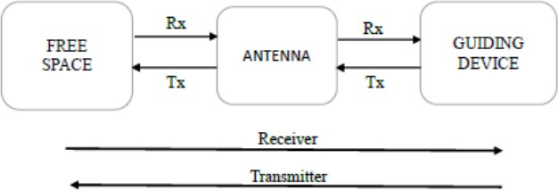

FIGURE 1.1 BASIC BLOCK DIAGRAM DEPICTING THE ROLE OF ANTENNA IN TRANSMISSION AND RECEPTION

The equivalent circuit of an antenna is given in Figure 1.2 as one can see that there is an impedance (Zg) at the generator. The characteristic impedance of the transmission line (Zc) which does not depend on the length of the transmission line but depends upon the material used in the transmission line and the impedance matching.

The impedance of the antenna (Za) is given by:

## Za = (Rl + Rr) + j Xa

Where,

Rl is the conduction and dielectric loss

Rr is the radiation resistance Xa is the radiation impedance

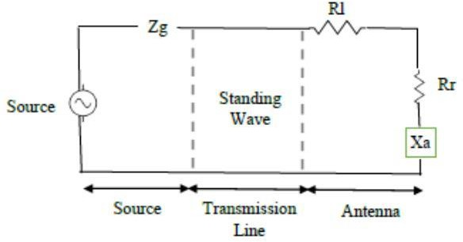

FIGURE 1.2 EQUIVALENT CIRCUIT DIAGRAM OF THE ANTENNA AS A GUIDING DEVICE

There are several ways to classify the antennas. If we classify on basis of frequency band we can have narrowband, wideband and ultra-wideband antennas. The antennas can be considered to be classified on the basis of electromagnetic, physical or electrical structure. Directionality also defines the classification in antenna as they can be directional and non-directional in nature. There can be different types of antenna, the following chart in Figure 1.3 depicts the different types of antenna and their combinations or derivatives.

The main antenna and their types are mentioned herewith.

* Conducting Wire: They are mainly constituted of a single wire. These are further arranged in form of dipoles, loops and helixes.
* Apertures: They consist of a radiating aperture for higher directivity. These are further subdivided to waveguides and horns.

Patch (Microstrip): These are the majorly used in embedded applications. They can be of various shapes like rectangular, circular etc.

* Array of elements: they consist of a group of smaller antennas excited at a fixed phase difference to generate high directivity.

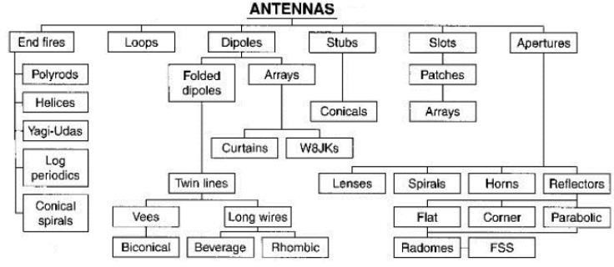

FIGURE 1.3 CLASSIFICATION OF ANTENNA ON BASIS OF PHYSICAL STRUCTURE

#### Need of Antenna

Antennas are crucial parts of numerous communication systems and have several uses. Here are some reasons why antennas are needed:

**Transmitting and Receiving Signals**: Antennas are used in a variety of communication systems, including radio, television, satellite, and cellular networks, to transmit and receive signals.

**Signal Strength**: Antennas are used to increase a transmitted signal's signal strength so that it can reach farther distances.

**Directional Reception**: Antennas can be made to only pick up signals coming from a specific angle, enabling directional communication and reducing interference from outside sources.

#### Radiation Mechanism

Electromagnetic radiation is created when electric charges are accelerated. Therefore, the source of radiation is the movement of charges or current. Here, it should be noted that not all current distributions will result in radiation that is potent enough for transmission. Electromagnetic energy is transmitted, coupled, concentrated, or directed via antennas in the desired or assigned direction. An antenna may be isotropic, anisotropic, directional, or Non directional (omnidirectional). Acceptable parameters include the antenna's shape, size, weight, gain, efficiency, impedance, frequency characteristics, and radiation pattern.

For transmitting antennas, high gain and directivity are essential. While low side lobes and a high signal-to-noise ratio are important considerations when choosing receiving antennas. Antenna may vary in size from the order of few millimeters (strip antenna) to thousands of feet (dish antennas for astronomical observations) To give a mathematical equation to it, as we know

A = μI dl

4πr

## dl𝑑𝑙 = dlq dv = dlqa

E = −∇V = 𝛛A

𝑑𝑡

= −∇V − μdl

𝛛𝑙

dt

= −∇V − μ dl

qa (1.1)

𝛛t

4πr 𝛛𝑡

4πr

As shown in these equations, to create radiation (electric field), there must be a time varying current dI/dt or an acceleration (or deceleration) a of a charge q. No radiation occurs if the wire is straight while a charge is travelling with uniform velocity, but radiation that is unlimited in extent occurs if the wire is curved, bent, discontinuous, or terminated. figure 1.4 shows the antenna radiation mechanism

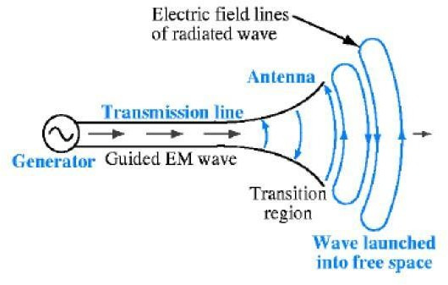

FIGURE 1.4 ANTENNA RADIATION MECHANISM

#### Antenna Parameters

* + - 1. The generator's right side is positive, and its left side is negative at any given time. According to a physics rule, similar charges repel one another. As a result, electrons will gravitate towards the positive terminal while moving as far away from the negative terminal as they can.
      2. The generator creates it after a quarter cycle, at which point the current and voltage reach their minimal values. Although there is no current flowing, there are a minimum number of electrons at the left end and a minimum number at the right end of the line.

The figure 5.1 shows the detailes flow of basic parameter,

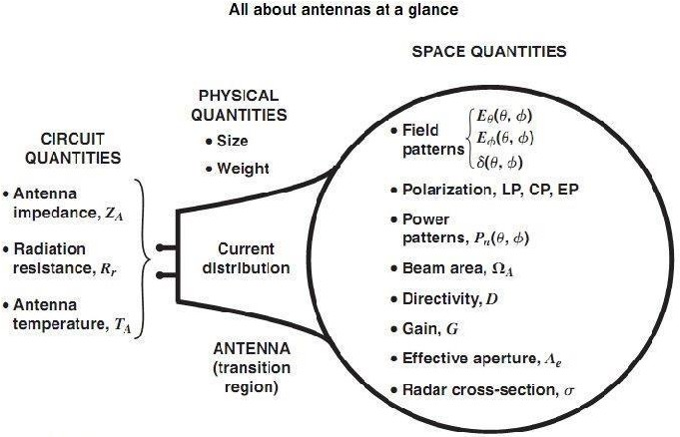

FIGURE 1.5 SCHEMATIC DIAGRAM OF BASIC PARAMETERS

#### Gain

Gain is a statistic used to evaluate the directionality of an antenna. A low gain antenna radiates with nearly the same power in all directions, in contrast to a high gain antenna, which preferentially radiates in some directions. In example, the difference between the signal intensity radiated in each direction by the S11 antenna at a given distance and the signal intensity radiated in the same distance by a hypothetical isotropic lossless antenna is characterized as the gain, directive gain, or power gain of an antenna. Since the radiation intensity from a lossless isotropic antenna equals the power into the antenna divided by a solid angle of 4π Steradians, the gain formula is defined by equation 1.2.

Gain = 4π radiation intensity total input (transmitted )power

(1.2)

#### Directivity

The radiation intensity from the antenna divided by the radiation intensity averaged over all directions is the definition of the antenna's directivity.

The total power radiated by the antenna divided by four determines the average radiation intensity.

#### Return Loss (S11)

A measure called the Return Loss (RL) shows how much power is sent to the load and does not come back as a reflection. When the transmitter and antenna impedances are not the same, waves are reflected, resulting in the development of standing waves. Consequently, the RL is a parameter to show S11 how well the transmitter and antenna have been matched. The RL is given by equation 1.3.

S11 = 10 log 10 pi

pr

(1.3)

Where pi -incident power, pr-reflected power and S11return loss

|  |  |  |
| --- | --- | --- |
| **Return Loss (dB)** | **Reflected Power (%)** | **Match Quality** |
| 0 dB | 100% | Total mismatch |
| -3 dB | 50% | Poor match |
| -10 dB | ~10% | Acceptable for many systems |
| -15 dB | ~3.2% | Good match |
| -20 dB | ~1% | Very good match |
| -30 dB | ~0.1% | Excellent match |

TABLE 1.1 INFERENCE S11 VALUES

#### Polarization

When choosing and installing an antenna, antenna polarization is a key factor. Because an antenna's radiation characteristics depend on its polarization, signals won't be received by the receiving antenna even if the transmitting and receiving antenna's resonance frequencies are exactly matched. The electric field or “E” plane determines the polarization or orientation of the wave. An antenna is vertically linear polarized when its electric field is perpendicular to the Earth’s surface.

#### Voltage Standing Wave Ratio (VSWR)

Electromagnetic waves may experience variations in impedance at each interface as they pass through the many components of the antenna system, from the source through the feed line to the antenna and finally to free space. 12 Standing waves in the feed line are caused by a portion of the wave's energy reflecting to the source depending on the impedance match.

A VSWR of 1:1 is ideal. A VSWR of 1.5:1 is marginally acceptable in low power applications. The VSWR value will be decreased, and power transfer through each component of the system will be maximized, by minimizing impedance differences at each interface.

VSWR = 𝑉𝑚𝑎𝑥 = 1 + |𝛤|

(1.4)

𝑉𝑚𝑖𝑛

1 − |𝛤|

#### Bandwidth

The antenna operating frequency band within which the antenna operates as intended is known as the bandwidth. The ratio of the higher to lower operating frequencies can be used to define the bandwidth of a broadband antenna. The absolute bandwidth (ABW) is defined as the difference of the two edges and the fractional bandwidth (FBW) is designated as the percentage of the frequency difference over the Centre frequency, given as shown in equation 1.

|  |  |  |  |
| --- | --- | --- | --- |
| **VSWR Value** | **Reflection (%)** | **Matching Quality** | **Efficiency** |
| 1.0 | 0% | Perfect match | 100% of power delivered |
| 1.5 | ~4% | Good match | ~96% power delivered |
| 2.0 | ~11% | Acceptable for many applications | ~89% power delivered |
| >2.0 | >11% | Poor match | Significant power reflection |

TABLE 1.2 INFERENCE VSWR VALUES

#### Radiation Pattern

As a mathematical function or a graphical representation of the radiation properties of the antenna as a function of space coordinates," the radiation pattern of an antenna is described. The radiation pattern is typically determined in the far field region and is shown as a function of directional coordinates. Power flux density, radiation intensity, field strength, directivity, phase, and polarization are examples of radiation qualities. The term "lobe" refers to a variety of radiation pattern elements.

Major, minor, side, and back lobes are the several subtypes of lobes. The definition of a major lobe, also known as the main beam, is "the radiation lobe containing the direction of maximum radiation." Any lobe that is not a major lobe” is a minor lobe. A side lobe is “a radiation lobe in any direction other than the intended lobe.” (Usually, a side lobe is adjacent to the main lobe and occupies the hemisphere in the direction of the main beam.) "A radiation lobe

whose axis makes an angle of about 180° with respect to the beam of an antenna," according to the definition, is a rear lobe.

# CHAPTER 2 LITERATURE SURVEY

**TITLE:** Left-handed metamaterial based on circular split ring (CSRR) resonator for microwave sensing Application

**AUTHOR:** Khalid Almuhanna , Sharul Kamal, Abdul Rahim , Md Samsuzzaman

**YEAR:**2024 **DESCRIPTION:**

The research paper titled *"* Left-Handed Metamaterial Based on Circular Split Ring (CSRR) Resonator for Microwave Sensing Application", published in Optical Materials (June 2024), presents the design and analysis of a compact metamaterial structure incorporating circular Complementary Split Ring Resonators (CSRRs). This design is optimized to function within the L, S, and C microwave bands (1–6 GHz), making it suitable for a wide range of sensing applications. The proposed metamaterial demonstrates left-handed behavior, characterized by negative permittivity and permeability, which leads to enhanced electromagnetic field confinement and sensitivity.

Through full-wave simulation and performance validation, the authors show that the CSRR structure produces sharp resonance responses with minimal loss and a strong dependence on surrounding dielectric changes. This sensitivity makes the design highly effective for non-contact and non-destructive sensing, such as in biomedical monitoring or material characterization. Additionally, its planar and miniaturized configuration enables easy integration with modern electronic and wireless systems. The work contributes significantly to the growing field of microwave metamaterials, offering a viable solution for developing high-performance, low-profile sensors with precise detection capabilities in complex environments.

**TITLE:** Metamaterial-Inspired Circularly Polarized Antenna for Implantable Biomedical Applications

**AUTHOR:** Siddhant Goswami, Deepak C. Karia.

**YEAR:**2020 **DESCRIPTION:**

This report presents the design and development of a compact, dual- band microstrip-fed antenna for implantable biomedical applications, operating within the 2.4–2.5 GHz ISM band. Utilizing circular polarization, the antenna minimizes polarization mismatch, ensuring reliable communication within the human body. The integration of metamaterial structures, specifically split ring resonators (SRRs), allows for significant miniaturization—achieving an 84% reduction in size compared to conventional designs—while maintaining high performance with a measured gain of 4.86 dB and an impedance bandwidth of 140 MHz.

The antenna is fabricated on an FR4 substrate and rigorously tested through both simulation and experimentation. The report also discusses the creation of human body-equivalent phantom liquids for in-vitro testing, with dielectric properties measured using the 85070E dielectric probe kit. A correlation between pH levels and permittivity is established, aiding future biomedical research.

This work contributes to the development of efficient antennas for wireless body area networks (WBANs) and implantable medical devices.

**TITLE:** A Review on Miniature Bio-Implant Antenna Performance Enhancement and Impact Analysis on Body Fluids in Medical Application

**AUTHOR:** Muthukumara Rajaguru Kattiakara Muni Samy and Abhishek Gudipalli

**YEAR:**2023 **DESCRIPTION:**

This review examines recent advancements in the design and performance of miniature bio-implantable antennas for biomedical applications. It focuses on challenges such as the negative impact of body fluids on antenna gain and radiation efficiency. The paper evaluates various antenna designs, materials, and configurations to improve communication between implanted devices and external monitoring systems, particularly within MICS (401–406 MHz) and ISM (2.4–2.48 GHz) frequency bands.

Key topics include biocompatibility, miniaturization techniques, electromagnetic simulations, and integration with biomedical sensors for real- time monitoring of parameters like glucose levels, brain activity, cardiac signals, and blood pressure. The review also covers in vitro and in vivo testing, fabrication processes, and performance metrics such as return loss, SAR, and gain. This paper provides valuable insights for researchers and engineers working on efficient, compact, and safe wireless medical telemetry systems.

**TITLE:** Dual-Band Metamaterial-Based EBG Antenna for Wearable Wireless Devices

**AUTHOR:** [Trong Hieu Dam](https://onlinelibrary.wiley.com/authored-by/Dam/Trong%2BHieu), [Minh Thuy Le](https://onlinelibrary.wiley.com/authored-by/Le/Minh%2BThuy), [Quoc Cuong Nguyen](https://onlinelibrary.wiley.com/authored-by/Nguyen/Quoc%2BCuong), [Thanh Tung](https://onlinelibrary.wiley.com/authored-by/Nguyen/Thanh%2BTung) [Nguyen](https://onlinelibrary.wiley.com/authored-by/Nguyen/Thanh%2BTung)

**YEAR:**2023 **DESCRIPTION:**

This paper presents a wearable dual-band T-shaped antenna designed for on-body wireless communication applications, operating at 2.4 GHz and 5.2 GHz. The antenna uses a coplanar waveguide (CPW) feed and is evaluated without and with a metamaterial-based electromagnetic bandgap (EBG) layer. Without the EBG layer, the antenna covers two frequency bands: 1.96 GHz to

2.77 GHz and 5.07 GHz to 5.35 GHz. However, when placed on the human arm, the antenna's efficiency is reduced due to interference from the human body, leading to a high specific absorption rate (SAR). The introduction of the EBG layer significantly reduces SAR values by 77.1% at 2.4 GHz and 91.7% at 5.2 GHz, improving antenna gain to 1.4 dBi at 2.4 GHz and 6.25 dBi at 5.2 GHz. The antenna prototype is tested with a Wi-Fi wearable device, showing an improvement in the signal-to-noise ratio (SNR) by 6-12 dB.

**TITLE:** Design a Dual-Band with CSRR Cascaded Patch Antenna Array for Wireless Communications

**AUTHOR:** Maloth Chandrasekhar,Ketavath Kumar Naik

**YEAR:**2024 **DESCRIPTION:**

The paper titled *"*A Dual-Band Cascaded Rectangular Microstrip Patch Antenna Array Using CSRR for Narrow Band Wireless Applications*"*, published in 2024 in the Progress In Electromagnetics Research (PIER) journal, explores the integration of Complementary Split Ring Resonators (CSRRs) in microstrip patch antennas to achieve efficient dual-band performance. The proposed antenna design features a cascaded rectangular patch structure with etched CSRRs on the

ground plane, which enables resonance at two distinct frequency bands. By leveraging the unique electromagnetic properties of CSRRs—specifically, their ability to introduce negative permittivity—the antenna demonstrates enhanced miniaturization, reduced return loss, and improved impedance matching.

The dual-band nature of the antenna makes it particularly suitable for narrow- band wireless applications such as RFID, WLAN, and IoT systems. The design maintains a compact footprint, while still achieving high gain and stable radiation patterns across both operating bands. Simulated and measured results validate the effectiveness of the CSRR-loaded structure, showing good agreement in return loss, bandwidth, and gain characteristics. This study highlights the practical benefits of metamaterial-inspired designs in advanced antenna engineering, providing a promising pathway for the development of efficient, space- conserving antennas for next-generation wireless communication systems.

**TITLE:** An extensive review on implantable antennas for biomedical applications: Health considerations, geometries, fabrication techniques, and challenges

**AUTHOR:** Md. Rokunuzzaman, Mohammad Tariqul Islam, Norbahiah Misran, Norsuzlin Bt Mohd Sahar, Md. Samsuzzaman

**YEAR:**2020 **DESCRIPTION:**

This review provides a comprehensive analysis of implantable antennas used in biomedical applications, focusing on key design considerations critical for their success. It examines factors such as biocompatibility, miniaturization, Specific Absorption Rate (SAR), and communication efficiency,

which are essential for ensuring the antenna’s safety and effectiveness within the human body. The paper categorizes different antenna geometries, including dipole, patch, loop, and spiral, evaluating their suitability for biomedical implants. Additionally, it explores various fabrication materials and techniques that can be employed for antenna construction, considering the need for materials that are both functional and biocompatible.

The review also addresses significant challenges encountered in real- world applications, such as achieving effective impedance matching in lossy biological tissues and ensuring long-term performance stability.

**CHAPTER 3 COMPLEMENTARY SPLIT RING RESONATOR,**

**DEFECTED GROUND STRUCTURE**

* 1. **METAMATERIALS**

#### Introduction

A type of synthetic materials called metamaterials is created to have characteristics that are not present in materials that occur naturally. They often consist of periodic arrangements of subwavelength - sized structures, which gives them their special features. These structures can be designed to manipulate electromagnetic waves, sound waves, or other types of waves in ways that are not possible with conventional materials. Since its initial introduction in the late 1990s, metamaterials have drawn a lot of interest from researchers across a variety of disciplines, including physics, engineering, and materials science.

One of the most important characteristics of metamaterials is their capacity for negative refractive indices, which allows them to bend light in the opposite direction from that of ordinary materials. A wide range of potential uses, such as lenses, cloaking devices, and super lenses that can resolve features smaller than the wavelength of light, have been made possible by this ability. Metamaterials are appealing for use in aerospace and other industries because they may be manufactured to have exceptional mechanical properties, including a negative Poisson's ratio or a high stiffness-to-weight ratio.

# SPLIT RING RESONATOR (SRR)

#### Introduction

The figure 3.1 shows Split Ring Resonator (SRR) which is one of the most fundamental building blocks in the field of metamaterials, widely used to manipulate electromagnetic waves in ways that natural materials cannot achieve.

First introduced by Pendry et al. in the late 1990s, SRRs are artificial structures that exhibit **negative permeability** within certain frequency ranges, making them essential in the development of **left-handed** or **negative-index** materials.

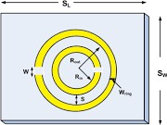

FIGURE 3.1 SPLIT RING RESONATOR

#### Structure and Operating Principle

An SRR typically consists of one or more concentric metallic rings with **narrow splits (gaps)** on opposite sides. These rings are usually fabricated on a dielectric substrate and are designed to resonate at a specific frequency when subjected to a time-varying magnetic field perpendicular to the plane of the rings.

When an external magnetic field interacts with the SRR, it induces circulating currents around the rings, creating a **magnetic dipole**. This artificial magnetic response gives rise to a region where the **effective magnetic permeability (μ)** becomes negative. The resonance behavior is a result of the structure acting like an **LC circuit**, with the metallic ring contributing inductance and the split providing capacitance. The resonance frequency f0 is given by:

f = 1 2π√LC

0

(3.1)

where L and C are the equivalent inductance and capacitance of the SRR.

#### Applications

SRRs have become indispensable in numerous electromagnetic applications:

* + - * **Metamaterials**: SRRs are the backbone of artificial magnetic materials and are often combined with wires or other elements to produce negative-index materials.
      * **Miniaturized Filters and Resonators**: Due to their compact size and tunable nature, SRRs are ideal for compact filter designs.

# COMPLEMENTARY SPLIT RING RESONATOR (CSRR)

#### Introduction

The increasing demand for compact, high-performance, and multi- functional devices has pushed the boundaries of conventional microwave and antenna engineering. One of the most significant breakthroughs in this field is the development and integration of metamaterials—engineered materials exhibiting electromagnetic properties not commonly found in nature. Among various metamaterial structures, the figure 3.2 shows a **Complementary Split Ring Resonator (CSRR)** has emerged as a highly versatile and powerful component, particularly in the design of miniaturized antennas and microwave circuits.



FIGURE 3.2 COMPLEMENTARY SPLIT RING RESONATOR

CSRRs are the negative counterparts of Split Ring Resonators (SRRs), and they are typically etched into the ground plane of planar transmission lines or microstrip structures. Their unique electromagnetic response enables

them to introduce negative permittivity, thereby allowing engineers to manipulate wave propagation in unconventional ways. In the context of antenna design, especially for biomedical and dual-band applications, CSRRs offer several key advantages, such as miniaturization, frequency selectivity, and enhanced radiation characteristics.

#### Theory and Operating Principle

The CSRR operates based on the concept of negative effective permittivity. While conventional dielectric materials possess a positive permittivity, the CSRR, through its geometry and resonance behavior, creates a negative effective permittivity over a specific frequency band. This phenomenon is achieved through its complementary nature to the SRR.

An SRR consists of one or more concentric metallic rings with splits (gaps), which support magnetic resonance when excited by an external time- varying magnetic field. Its complement, the CSRR, is a slot-type structure etched into the ground plane or conductive layer, and it resonates under the influence of an electric field perpendicular to the slot orientation.

The resonance frequency f0 of a CSRR is primarily determined by its geometry and can be approximated as:

f = 1 2π√LC

0

(3.1)

where LLL is the equivalent inductance and CCC is the equivalent capacitance associated with the slot configuration. Changes in ring dimensions, gap size, and substrate material can shift the resonant frequency, making CSRRs highly tunable.

#### 3.3.3 Structure and Geometrical Parameters

A typical CSRR consists of one or two concentric rings with gaps placed on opposite sides of each ring. The slots are often etched onto the ground plane or the conductor layer of a microstrip line. The parameters influencing the performance of a CSRR include:

* + - * **Outer radius (r):** Affects the overall resonance frequency and effective area.
      * **Ring width (w):** Influences the capacitance and coupling between rings.
      * **Gap size (g):** Determines the electric field concentration and resonance strength.
      * **Spacing between rings (s):** Affects mutual coupling and bandwidth.
      * **Substrate properties:** The dielectric constant and thickness of the substrate influence the effective permittivity and miniaturization factor.

The flexibility in CSRR design allows for optimization depending on the target application—narrowband filters, dual-band antennas, or even sensors for biomedical monitoring.

#### CSRR in Antenna Design

Incorporating CSRRs into antenna systems leads to various performance enhancements, particularly in the areas of size reduction, multi-band operation, and bandwidth tuning. Below are several ways CSRRs are utilized in antenna engineering:

* + - * **Miniaturization:** CSRRs contribute to miniaturization by slowing down the phase velocity of the propagating wave, effectively reducing the physical length required for a given resonant frequency. such as biomedical telemetry and wireless body area networks (WBANs).
      * **Multi-band and Dual-band Operation:** By integrating multiple CSRRs with different dimensions or using nested ring configurations, antennas can be made to resonate at multiple frequencies.

#### Applications of CSRR-Loaded Systems

Complementary Split Ring Resonators find applications across various domains, including:

* + - * **Biomedical Antennas:** CSRRs enable compact and low-profile antennas suitable for implantable and wearable health monitoring devices. Their ability to operate efficiently within human tissues, where permittivity is high, makes them ideal for such applications.
      * **RF and Microwave Filters:** CSRRs are widely used in filter design to introduce sharp stop bands, improve selectivity, and reduce size.

#### Issuses And Implications

Despite their advantages, the integration of CSRRs into practical systems requires careful design and simulation:

* + - * **Substrate Losses:** High dielectric losses in the substrate can dampen the resonance and reduce efficiency.
      * **Fabrication Tolerances:** Small variations in dimensions can shift the resonant frequency, requiring precise fabrication.
      * **Tissue Interaction in Biomedical Use:** In wearable and implantable applications, human body tissues may detune the antenna or cause absorption losses. Accurate modeling and tissue-equivalent testing are crucial.

|  |  |  |
| --- | --- | --- |
| **Feature** | **SRR (Split Ring Resonator)** | **CSRR (Complementary Split Ring Resonator)** |
| **Structure** | Concentric metallic rings with splits (gaps) | Negative image (slots) of SRR etched on a metal surface |
| **Location in Circuit** | Placed on the signal path (microstrip or substrate) | Etched into the ground plane or conductor layer |
| **Resonance Type** | Magnetic resonance | Electric resonance |
| **Excitation Field** | Excited by magnetic field (normal to the plane) | Excited by electric field (parallel to the slots) |
| **Effective Medium Parameter** | Produces negative permeability (μ) | Produces negative permittivity (ε) |
| **Field Coupling** | Couples with magnetic field | Couples with electric field |
| **Use in Metamaterials** | Used to design μ- negative (MNG) or left-handed materials | Used to design ε-negative (ENG) or left-handed materials |
| **Design Application** | Common in artificial magnetic materials, filters, and cloaking | Common in filters, compact antennas, and DGS-based designs |
| **Current Flow** | Induced circulating currents around the ring | Induced surface currents around the slot edges |
| **Miniaturization** | Effective for miniaturizing resonators and filters | Effective for miniaturizing antennas and enhancing selectivity |
| **Substrate Interaction** | Influenced by substrate thickness and dielectric constant | Also influenced by substrate, but mainly affects ground behavior |

Table 3.1 CSRR vs SRR

# DEFECTED GROUND STRUCTURE (DGS)

**Defected Ground Structure (DGS)** refers to a deliberate modification or etching of a pattern (such as slots or shapes) in the ground plane of a microstrip circuit or antenna. This disruption in the ground plane alters the current distribution and electromagnetic properties, allowing designers to **control the antenna’s performance** in terms of bandwidth, impedance, and radiation characteristics.

#### Key Features of DGS:

* + - * **Improves impedance matching** by modifying the current flow in the ground.
      * **Enables miniaturization** by introducing slow-wave effects.
      * **Enhances bandwidth** and **gain** in many antenna designs.
      * Can be used to **suppress surface waves** and reduce mutual coupling in MIMO systems.

The figure 3.3 shows a example of “defective Ground Surface”,



FIGURE 3.3 DEFECTIVE GROUND STRUCTURE

#### Bandwidth Enhancement by Defective Ground Surface (DGS)

Defective Ground Surface (DGS) enhances bandwidth by modifying the ground plane structure with intentional defects, such as slots or etched patterns. These changes alter the current distribution and electromagnetic wave

propagation, leading to improvements in performance. Here's how DGS contributes to bandwidth enhancement:

* + - * **Improved Impedance Matching** – DGS introduces capacitance and inductance variations that help in better impedance matching, reducing reflection losses and broadening the operating frequency range.
      * **Reduction of Surface Wave Effects** – By disrupting surface wave propagation, DGS minimizes losses and extends bandwidth in antenna and circuit designs.

### GROUND SURFACE FLAW EFFECTS

Defective Ground Surface (DGS) is an effective technique for achieving **miniaturization** in RF and microwave devices, including antennas and filters. By introducing patterned defects in the ground plane, DGS modifies the electromagnetic characteristics of the system, leading to size reduction without sacrificing performance. Here’s how DGS contributes to compact designs:

* + - * **Artificial Inductance and Capacitance** – The defects introduce additional inductive and capacitive elements, allowing designers to achieve resonance with smaller physical dimensions.
      * **Lower Resonance Frequency** – DGS shifts the resonance frequency downward, enabling operation at lower frequencies while maintaining compact size.

# SPECIFIC ABSORPTION RATE (SAR) IN ANTENNA DESIGN

**Specific Absorption Rate (SAR)** which is shown in the diagram 3.4 is a crucial parameter in the design and evaluation of antennas intended for **biomedical**, **wearable**, or **implantable** applications. It quantifies the rate at

which the human body absorbs electromagnetic energy when exposed to a radiofrequency (RF) electromagnetic field.

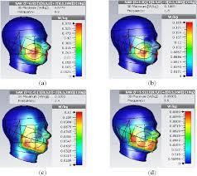

FIGURE 3.4 SPECIFIC ABSORPTION RATE

#### Definition:

SAR is defined as the power absorbed per unit mass of biological

tissue and is expressed in units of **watts per kilogram (W/kg)**.

Where:

SAR = σ|E|2

𝞀

(3.2)

**σ** = electrical conductivity of the tissue (S/m)

∣ **E**∣ = magnitude of the electric field (V/m)

**ρ** = mass density of the tissue (kg/m³)

### IMPORTANCE OF SAR IN ANTENNA DESIGN:

1. **Human Safety**: SAR helps ensure that the antenna does not cause harmful heating of human tissue when in close proximity or implanted inside the body.
2. **Regulatory Compliance**: Regulatory bodies like the **FCC** (USA), **ICNIRP**

(International), and **IEEE** specify SAR limits to protect human health.

For example, the FCC limit is:

* + **1.6 W/kg averaged over 1g of tissue** (in the US)
  + **2.0 W/kg over 10g of tissue** (in Europe and international standards)

1. **Design Optimization**: Antenna design must balance performance (gain, bandwidth, efficiency) while minimizing SAR. This is often done by:
   * Using **low-power radiation**
   * Positioning the antenna away from critical organs
   * Employing **ground planes**, **metamaterials**, or **shielding layers**
   * Adjusting the **geometry** to direct radiation away from the body.

# MICROSTRIP FEED LINE TECHNIQUE

The **microstrip feed line** is one of the most widely used feeding techniques in planar antenna structures, particularly for compact, low-profile antennas such as microstrip patch antennas. This method involves a conducting strip (feed line) printed on the same substrate as the antenna, typically on the opposite side of the ground plane.

#### Working Principle:

The microstrip feed line delivers RF power to the radiating patch by directly connecting to it or through a coupling mechanism (such as inset or proximity coupling). The width of the feed line is carefully chosen to achieve a desired **characteristic impedance** (typically 50 ohms) to ensure proper impedance matching and minimal signal reflection.

#### Advantages:

* + - * Easy to fabricate using standard PCB processes.
      * Compact and low-profile.
      * Supports integration with active/passive circuit components.

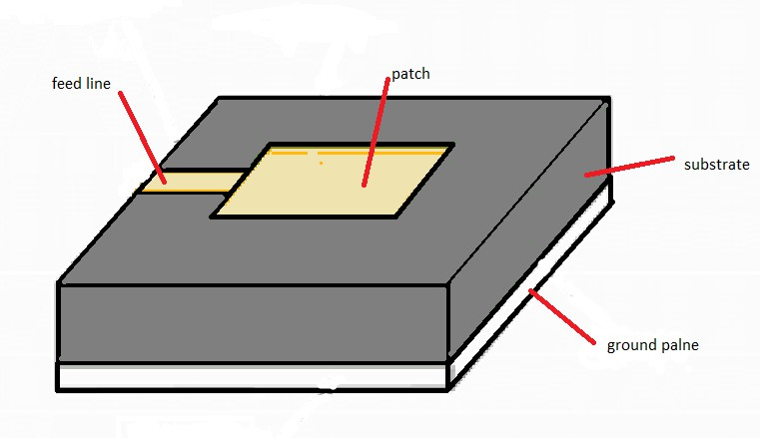

FIGURE 3.5 MICROSTRIP FEED LINE TECHNIQUE

### FEED LINE WIDTH CALCULATION

For a given substrate height h and dielectric constant εr the width Wf of a microstrip line for 50 Ω impedance can be approximated by:

Where:

𝑊𝑓 ℎ

8𝑒𝐴

−2+𝑒2𝐴 (3.3)

=

## A = 𝑍0

60

𝗌𝑟 + 1

2

√

+ 𝗌𝑟 − 1

𝗌𝑟 + 1

## (0.23 +

0.11

𝗌𝑟

) (3.4)

Z0 = desired impedance (typically 50 Ω) εr = dielectric constant of the substrate

|  |  |  |  |  |
| --- | --- | --- | --- | --- |
| **Feed Type Property** | **Microstrip Line Feed** | **Coaxial Feed** | **Aperture Coupling Feed** | **Proximity Coupling Feed** |
| **Spurious Feed Radiation** | More | More | Less | Minimum |
| **Polarization Purity** | Poor | Poor | Excellent | Poor |
| **Reliability** | Better | Poor due to soldering | Good | Good |
| **Ease of**  **Fabrication** | Easy | Soldering and drilling needed | Alignment required | Alignment required |
| **Impedance Matching** | Easy | Easy | Easy | Easy |
| **Bandwidth** | 2–5% | 2–5% | 2–5% | 13% |

TABLE 3.2 COMPARISON AMONG VARIOUS FEEDING METHODS

# ROGERS AD 430 AND IT’S ADVANTAGE

**Rogers AD430** is a high-performance laminate material commonly used in RF and microwave applications. Manufactured by Rogers Corporation, it is part of the **RO4000 series** of materials, which are known for combining excellent electrical properties with mechanical stability and ease of fabrication.

|  |  |
| --- | --- |
| **Property** | **Value** |
| Dielectric Constant (εr) | ~4.3 ± 0.05 |
| Loss Tangent (tanδ) | ~0.003 at 2.5 GHz |
| Thickness Availability | Various (e.g., 0.508 mm) |
| Thermal Conductivity | ~0.6 W/m·K |
| Operating Temperature | Up to 150°C |
| Moisture Absorption | Low (~0.06%) |
| Conductor Compatibility | Compatible with standard copper cladding |

TABLE 3.3 KEY PROPERTIES OF ROGERS AD430

#### Stable Dielectric Constant (εr ≈ 4.3)

* + Ensures predictable and repeatable performance across a wide range of frequencies.
  + Facilitates accurate impedance matching and bandwidth control, which is critical in dual-band and biomedical antennas.

#### Low Loss Tangent

* + The low loss tangent (~0.003) minimizes **dielectric losses**, which improves

#### antenna efficiency and radiation performance.

* + Especially beneficial in high-frequency designs (e.g., ISM band, 2.4 GHz and above).

# CHAPTER 4 CST SOFTWARE

CST Software, short for **Computer Simulation Technology** software, is a leading suite of simulation tools primarily used for electromagnetic (EM) field analysis. This software is widely used for designing and analyzing components and systems that involve electromagnetic fields, such as antennas, microwave circuits, radar systems, wireless devices, and more. CST Software is developed by CST - Computer Simulation Technology AG, which is now a part of SIMULIA, a Dassault Systèmes brand.

# OVERVIEW OF CST SOFTWARE

* + - **CST Studio Suite**: The flagship product of CST, this software includes multiple simulation tools and solvers for a wide range of applications. It offers a comprehensive and user-friendly environment for the design, analysis, and optimization of electromagnetic systems.
    - **Solvers**: CST Software includes several solvers that use different numerical techniques for simulating electromagnetic fields. Some of the common solvers include:
    - **Time Domain Solver**: Suitable for broadband simulations and transient analysis.

# KEY FEATURES OF CST SOFTWARE

* **Multi-Physics Simulation**: CST can simulate not only electromagnetic phenomena but also coupling with other physical effects such as thermal, mechanical, and fluid simulations.
* **Automation & Optimization**: CST Studio offers tools for automating repetitive tasks, optimizing designs, and improving the efficiency of simulations.
* **3D and 2D Simulation**: It provides both 3D and 2D modeling tools for simulating complex geometries and structures.

# APPLICATIONS OF CST SOFTWARE

* **Antenna Design**: CST is frequently used to design and optimize antennas for various applications, including mobile communication, satellites, and radars.
* **Microwave Engineering**: It is used to simulate and optimize microwave components such as filters, couplers, and waveguides.
* **Signal Integrity and EMI/EMC**: CST helps in designing electronic circuits with proper signal integrity and electromagnetic compatibility (EMC), ensuring compliance with regulatory standards.

# INTEGRATION AND COLLABORATION

* **CAD and EDA Tools**: CST integrates well with other Computer-Aided Design (CAD) and Electronic Design Automation (EDA) tools, allowing seamless interoperability in multi-disciplinary design workflows.
* **Cloud and HPC**: The software supports cloud computing and High- Performance Computing (HPC), which is critical for running large-scale simulations efficiently

# ADVANTAGES OF USING CST OVER HFSS

### FASTER SOLVERS AND SIMULATION SPEED

* + - * **Time-Domain Solver**: One of the most significant advantages of CST over HFSS is its **Time-Domain Solver**, which is known for faster simulations,

especially for broadband applications. This solver is highly efficient for transient analysis and can handle large models quickly.

* + - * **Faster Convergence**: CST tends to converge faster in simulations involving wideband problems, multi-frequency analysis, and transient responses compared to HFSS, which can be slower due to its reliance on the frequency- domain solver.

### BROAD RANGE OF SOLVERS

* + - * **Multiple Solver Options**: CST provides multiple solvers for different types of problems, such as **Time-Domain**, **Frequency-Domain**, **Integral Equation**, and **MoM (Method of Moments)** solvers, giving users more flexibility and the ability to choose the most appropriate solver for the problem.
      * **High Flexibility**: HFSS is primarily focused on the frequency-domain solver, while CST provides a broader selection of solvers, including both time- and frequency-domain solvers, allowing for more options depending on the nature of the problem.

### EASE OF USE AND USER INTERFACE

* + - * **Intuitive Interface**: CST's user interface is often considered more **user- friendly** and **intuitive** than HFSS. The process of setting up simulations, meshing, and post-processing is streamlined, making it easier for new users to get started.
      * **More Accessible for Multi-Physics Simulation**: CST supports multi- physics simulations (e.g., coupling electromagnetic fields with thermal, mechanical, or fluid simulations), which is easier to implement compared to HFSS. This makes CST a better choice for complex, multidisciplinary designs.

### FASTER POST-PROCESSING

* + - * **Advanced Post-Processing Tools**: CST has advanced and faster post- processing tools that allow users to visualize simulation results more efficiently. Its **3D visualization** and **field plotting** capabilities are often considered more powerful and faster than those in HFSS.
      * **Interactivity**: CST offers real-time visualization of simulation results, which can significantly speed up the design iteration process.

# CHAPTER 5 PROPOSED SYSTEM

**5.1 INTRODUCTION**

The proposed system focuses on the design and development of a **Complementary Split Ring Resonator (CSRR) loaded dual-band E-shaped slot antenna** specifically tailored for biomedical applications. The antenna structure is engineered to operate efficiently in two distinct frequency bands commonly utilized in biomedical telemetry and wireless body area networks (WBANs). By integrating the CSRR elements into the antenna design, enhanced miniaturization, improved impedance matching, and increased gain performance are achieved without compromising the radiation characteristics.

The E-shaped slot configuration is selected due to its ability to support dual-band operation and its compatibility with compact design requirements. Loading the slot with CSRRs allows for artificial magnetic conductors, leading to the development of multiple resonant paths and greater control over the resonant frequencies. This configuration makes the antenna highly suitable for implantable or wearable biomedical devices where size, bandwidth, and performance are critical constraints.

# Construction of Antenna Using CST:

First, the Microstrip patch antenna is designed. The basic structure of the antenna consists of ground, substrate, patch, feed

#### Design Equations for the Hexagonal Microstrip Patch Implant Antenna

The design of a hexagonal microstrip patch antenna for implantable biomedical applications requires precise calculations to ensure miniaturization,

biocompatibility, and efficient performance within the human body. The following equations are adapted and modified from the traditional rectangular patch design methodology, with considerations made for the unique geometry and dielectric environment.

#### Resonant Frequency (fr)

The fundamental resonant frequency for a patch antenna is approximated using:

Where:

fr = 𝑐

2𝐿𝑒𝑓𝑓√𝗌𝑒𝑓𝑓

(5.1)

**fr** = resonant frequency (Hz)

**c** = speed of light in vacuum (3×108 m/s)

**Leff** = effective length of the patch

**εeff** = effective dielectric constant of the substrate

#### Effective Dielectric Constant (εeff)

Due to fringing fields, the effective dielectric constant is given by:

𝜀 = 𝗌𝑟+1 + 𝗌𝑟 −1

−1

(1 + 12 ℎ ) 2 (5.2)

𝑒𝑓𝑓 2 2 𝑊

Where:

**εr** = relative permittivity of the substrate

**h** = thickness of the substrate

**W** = equivalent width of the patch

#### Patch Side Length for Hexagonal Geometry

For a regular hexagonal patch, the side length aaa can be estimated from an equivalent circular patch radius approximation:

3√3

ℎ𝑒𝑥 2

𝐴 =

2

## a2 ≈ πr2 → a ≈ √ e

aπr

3√3

(5.3)

#### Substrate Height Consideration

In implantable antennas, the substrate thickness is typically very low due to size constraints and tissue loading effects:

#### 0.5 mm≤h≤1.5 mm

1. **Miniaturization Using Metamaterials (e.g., CSRR)**

When metamaterial structures like Complementary Split Ring Resonators (CSRRs) are integrated, the effective permittivity and permeability of the substrate are altered. This enables further miniaturization:

**εeff,csrr>εr**⇒**fr↓**

Thus, the physical size of the antenna can be reduced for the same target frequency.

# DESIGN PROCEDURE OF PROPOSED ANTENNA

The following are the steps to be followed to design the antenna:

The figure 5.1,5.2,5.3 shows the step by step procedure of the atenna,

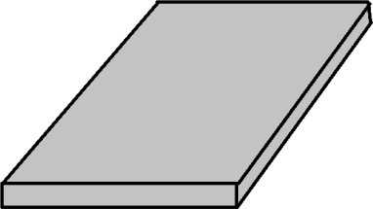 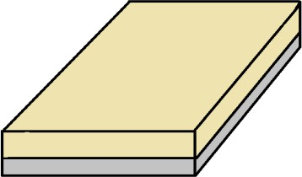

FIGURE 5.1 GROUND FIGURE 5.2 SUBSTRATE

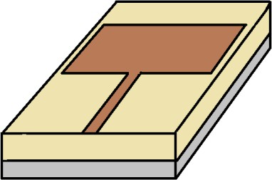

FIGURE 5.3 PATCH

### STEP 1 (GROUND)

The **ground plane** is a crucial component in antenna design, serving as a reference point for the return path of current and playing a vital role in defining the radiation characteristics and impedance behavior of the antenna. In this design, the ground structure includes etched slots that are deliberately introduced to improve performance parameters such as bandwidth, gain, and resonance frequency. The slotted structure helps in creating coupling effects and current path modifications, which can lead to dual-band or multiband behavior, particularly important for biomedical applications.

In this antenna design, the ground plane is constructed using copper, a material chosen for its excellent electrical conductivity and minimal resistive losses, which ensures efficient signal transmission. To enhance the antenna's

performance characteristics—particularly its bandwidth, impedance matching, and multi-band behavior—a Defective Ground Structure (DGS) is implemented. This involves introducing strategically shaped slots and defects into the ground plane, disrupting the surface current distribution.

### STEP 2 (SUBSTRATE)

The substrate is a key component in many antenna designs since it supports the antenna's structural integrity and affects its electromagnetic characteristics. In antenna design, the substrate is the material on which the antenna is constructed or mounted. The substrate material is an important consideration when building an antenna since it can affect the antenna's radiation effectiveness, bandwidth,

and other performance characteristics. The substrate is constructed of **Rogers AD 430** material, which has a **1 mm** thickness and dimensions of 25 X 25 mm2 as **L** and **W**.

### STEP 3 ( PATCH)

In contemporary communication systems, patches are a common type of antenna. A patch antenna is a kind of antenna that consists of a flat metal surface that is either rectangular or circular or a hexgonal and is often positioned above a ground plane. Typically, a coaxial cable or microstrip line connected to a transmitter or a receiver feeds the patch. Because they are very simple to develop, manufacture, and incorporate into complicated systems, patches are widely used. They may be made to have a relatively large bandwidth and are low- profile, making them appropriate for a variety of applications. For the ease of changing the dimensions the square shape is opted. Being a hexagonal patch the

current distribution among the sharp edges is not much easy, so the corner is cut in this design upto 1mm on the patch. The material of the patch used is copper.

# EVOLUTION THE ANTENNA

#### Stage 1

In the figure 5.4 is the initial stage of antenna design, a circular copper patch is placed on a Rogers AD430 substrate to resonate at 5.8 GHz, ideal for ISM band biomedical applications. Copper offers high conductivity for efficient radiation, while Rogers AD430 provides a stable dielectric constant, low loss tangent, and thermal stability, ensuring consistent performance. Its mechanical strength and moderate permittivity support compact designs suited for wearable biomedical devices. Although not inherently biocompatible, it performs reliably when encapsulated. These properties make Rogers AD430 a suitable substrate for biomedical antennas, offering efficient, stable, and compact solutions for health monitoring and wireless communication systems.

.

FIGURE 5.4 INITIAL STAGE

#### Stage 2

In the second phase (figure 5.5) of development, significant modifications are introduced to optimize the antenna for **implantable**

**biomedical applications**. The circular patch structure remains the foundation of the design; however, two critical advancements are made:



FIGURE 5.5 STAGE 2 OF PROPOSED ANTENNA

#### 1. U-Shaped Slot Integration

A **U-shaped slot** is etched into the circular patch to introduce an additional resonant frequency. This technique is commonly employed to achieve **multi-band operation** and fine-tune the frequency response. The slot dimensions are precisely defined as:

#### Length × Width × Thickness = 6 mm × 6 mm × 0.5 mm

This structural modification enables the antenna to resonate at a higher frequency of **7.8 GHz**, which is within the spectrum used for high-data- rate biomedical telemetry and diagnostic imaging.

This stage of the design illustrates a key transition toward practical application in implantable systems, paving the way for further enhancement using **metamaterials** and additional tuning elements.

#### Stage 3

In the third stage (figure 5.6) of the antenna development process, the design is further refined to achieve enhanced frequency tuning and multiband operation, which is essential for biomedical communication systems operating within diverse tissue environments.

#### Micro-Slot Addition in U-Shaped Structure

Building on the previous U-shaped slot configuration, an additional **small rectangular slot** is precisely introduced within the arms of the U-slot. This **micro-slot** has dimensions of **0.5 mm × 0.5 mm**.

This structural refinement shifts the antenna’s resonant behavior, enabling it to operate efficiently at a new frequency of **6.8 GHz**. The slight downward shift in resonant frequency, compared to the previous 7.8 GHz, offers:

* + - * **Improved spectral positioning** within the permissible medical telemetry bands.
      * **Better impedance matching** and bandwidth optimization.
      * **More compact and efficient performance**, suitable for implantable biomedical devices requiring precise control over operating frequencies.

The visualization shows the updated geometry where the micro-slot is embedded within the main U-slot region, subtly altering the electromagnetic field distribution and enhancing the tunability of the antenna without significantly affecting the overall size or complexity.

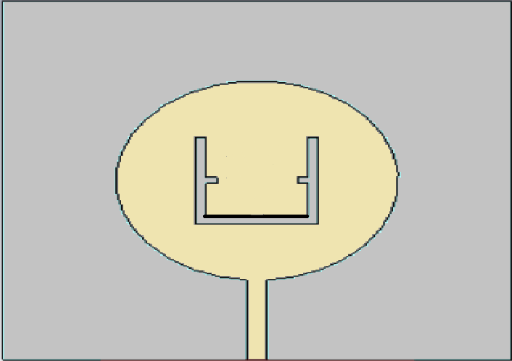

FIGURE 5.6 STAGE 3 OF PROPOSED ANTENNA

This stage demonstrates how **minor geometrical perturbations** can fine-tune antenna characteristics, which is crucial in the design of compact and efficient biomedical antennas.

#### Stage 4

In the fourth stage as shown in figure 5.7 of the design process, the antenna undergoes a major structural transformation aimed at optimizing its performance for specific biomedical communication bands. The design evolution culminates in a **hexagonal-shaped patch**, replacing the previous circular geometry.

#### Hexagonal Patch Integration with Embedded Slot Structure

The new **hexagonal patch** configuration is selected for its advantageous surface current distribution and compact form factor, both of which contribute to enhanced performance in miniaturized biomedical systems. Within the hexagonal patch, **multiple intricate slots** are introduced. These slots are strategically etched to fine-tune the resonant behavior of the antenna and ensure effective radiation at lower frequencies.

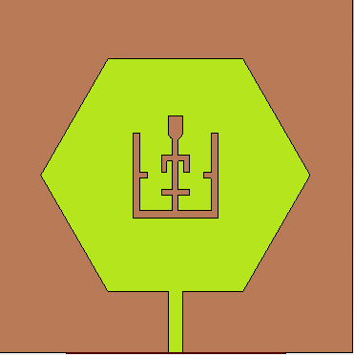

FIGURE 5.7 STAGE 4 OF PROPOSED ANTENNA

#### Performance Characteristics

* + - * **Resonant Frequency**: The antenna is now finely tuned to operate at **2.46 GHz**, a frequency within the **ISM band** commonly used in medical telemetry (e.g., for implantable and wearable health monitoring systems).
      * **Return Loss**: The antenna exhibits a return loss of **-21 dB**, indicating excellent impedance matching and minimal signal reflection.
      * **VSWR (Voltage Standing Wave Ratio)**: The VSWR value of **1.19** confirms strong impedance matching between the antenna and its feedline, ensuring efficient power transfer.

This structural innovation demonstrates the synergy of geometric optimization and slot-loading techniques, culminating in an antenna that is compact, efficient, and highly suited for **implantable biomedical telemetry**.

#### Stage 5

The fifth stage (figure 5.8) marks the transition of the antenna into a metamaterial-inspired structure optimized for triple-band operation. Building upon the previous hexagonal patch configuration, this phase introduces a

hexagonal ring resonator embedded within the patch, resulting in significantly enhanced multi-frequency performance.

A hexagonal ring is incorporated into the patch with a radius of 7.8 mm and a ring thickness of 0.5 mm. This resonant structure interacts with the electromagnetic fields to generate multiple current paths, which effectively creates multiple resonant modes within a compact footprint. The metamaterial behavior of the hexagonal ring enables selective frequency excitation while preserving miniaturization and low-profile design advantages.

#### Triple-Band Performance

This enhanced antenna design now supports **three distinct resonant frequencies**:

* + - * **2.4 GHz**: Ideal for ISM band applications such as Bluetooth and medical telemetry. It offers **low return loss**, indicating strong impedance matching.
      * **4.3 GHz**: A secondary resonant mode also characterized by **low return loss**, potentially useful for body area network communications.
      * **5.84 GHz**: The third resonance displays the best performance with a **return loss of -26.1 dB** and a **VSWR of 1.10**, confirming excellent impedance matching and minimal signal reflection at this band.

#### Significance and Application

The implementation of the hexagonal ring transforms the antenna into a triple-band device suitable for a broad range of biomedical communication systems. The wide frequency coverage ensures compatibility with multiple wireless standards, while the compact size and improved return loss make it an excellent candidate for implantable and wearable devices where space and power efficiency are critical.



FIGURE 5.8 STAGE 5 OF PROPOSED ANTENNA

This final configuration reflects the culmination of progressive geometric and material modifications aimed at achieving high-performance, multiband, and bio-compatible antenna operation.

#### Stage 6

In this refinement phase as shown in figure 5.9 , the antenna structure is carefully optimized by reducing the size of the hexagonal ring incorporated in the patch. This geometric alteration is strategically aimed at achieving precise multi-band frequency response, with improved performance across key biomedical communication bands.

#### Optimized Hexagonal Ring for Enhanced Triple-Band Operation

By minimizing the hexagonal ring’s dimensions, the antenna achieves a new balance between compactness and functional performance. This modification adjusts the electromagnetic coupling within the patch, allowing the antenna to operate at three distinct frequencies:

* + - * **2.46 GHz** – A frequency close to the ISM band, ideal for medical telemetry applications. This mode exhibits a **return loss of -16 dB** and a **VSWR of 1.37**, indicating good, though slightly reduced, impedance matching compared to the previous configuration.
      * **5.2 GHz and 5.8 GHz** – These higher bands now show **improved return loss values** compared to the 2.46 GHz frequency, demonstrating better impedance matching and stronger signal performance.

#### Design Implications

The reduced hexagonal ring design not only supports **triple-band functionality**

but also:

* + - * Enhances the compactness of the antenna.
      * Maintains metamaterial-inspired properties for efficient radiation.
      * Improves tuning flexibility for various wireless biomedical systems.

This sixth stage demonstrates the final level of design maturity, where performance optimization and structural efficiency are finely balanced to meet the stringent requirements of implantable and body-worn medical devices.

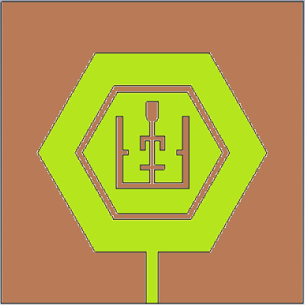

FIGURE 5.9 STAGE 6 OF PROPOSED ANTENNA

#### Stage 7

In this advanced stage, the antenna undergoes a significant structural enhancement with the integration of a split-ring resonator (SRR) into the existing hexagonal ring configuration. The split ring, having a thickness of 0.5 mm, is carefully engineered to manipulate the electromagnetic response and improve selectivity within targeted frequency bands.

#### Split-Ring Enhanced Hexagonal Structure

The introduction of the split in the hexagonal ring modifies the current path and coupling characteristics, creating localized magnetic resonance. This enables better control over the resonant modes and supports a tailored frequency response, making the antenna particularly efficient for specific biomedical communication applications.

#### Dual-Band Resonance Characteristics

The antenna now operates in **dual-band mode**, resonating at the following frequencies:

* + - * **2.4269 GHz**: This frequency lies within the ISM band, commonly used for low-power biomedical telemetry. It shows a **return loss of -15.29 dB** and a **VSWR of 1.41**, indicating decent impedance matching suitable for effective signal transmission with moderate reflection.
      * **5.8404 GHz**: A higher band that supports high-data-rate wireless biomedical applications, with an improved **return loss of -16.30 dB** and a **VSWR of 1.36**, reflecting enhanced radiation efficiency and better impedance characteristics.

#### Design Advantages

* + - * The split-ring structure enables dual-frequency resonance without increasing antenna size.
      * It preserves the compactness and miniaturization necessary for implantable or wearable biomedical devices.
      * The design balances moderate return loss with acceptable VSWR, making it suitable for narrowband medical telemetry systems.

This stage marks a refined culmination of the design process, demonstrating how metamaterial-inspired modifications, like split-ring integration, can precisely tailor antenna behavior for biomedical frequency bands.

# PROPOSED DESIGN

This work presents a compact dual-band antenna designed on a Rogers AD430 substrate with dimensions of 25 mm × 25 mm × 1.08 mm, aimed at biomedical applications. The antenna integrates a defective slotted ground and a hexagonal split-ring resonator (SRR) on the patch to enhance its dual-band response. The use of a metamaterial substrate contributes to improved performance and miniaturization.

The proposed antenna’s front view and the back view is shown in the figure 5.10,5.11.

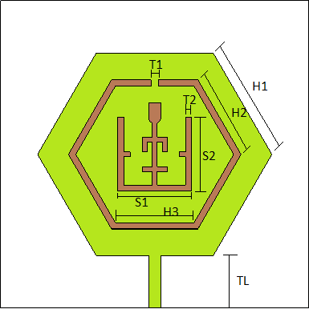

FIG URE 5.10 FRONT VIEW OF PATCH

|  |  |
| --- | --- |
| **PARAMETER** | **VALUE** |
| TL (Height of the Transmission Line) | 4.27mm |
| H3 (Inner Hexagonal Split Ring Length) | 6.40mm |
| H2 (Outer Hexagonal Split Ring Length) | 7.80mm |
| H1 (Hexagonal Patch Length) | 9.5mm |
| S1 (Length of the E-Slot) | 6mm |
| S2 (Height of the E-Slot) | 6mm |
| T1 (Thickness of E-Slot) | 0.5mm |
| T2 (Thickness of the Split Ring) | 0.6mm |

TABLE 5.1 DIMENSIONS OF PATCH

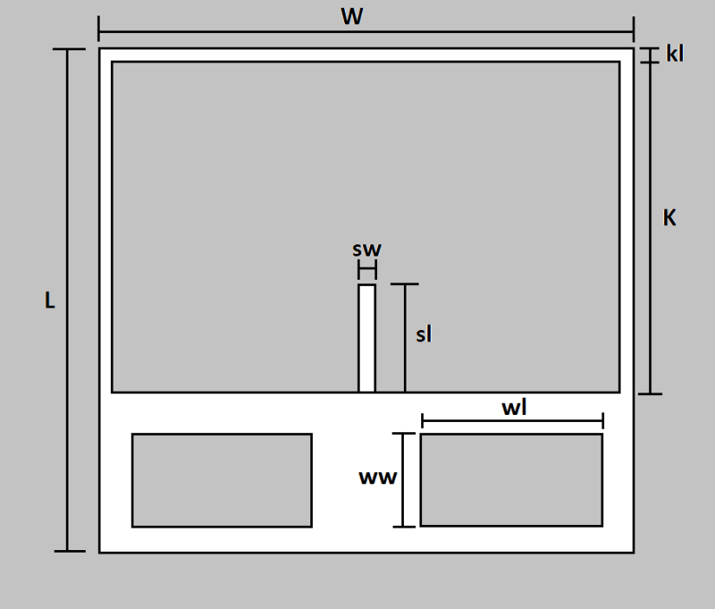

FIGURE 5.11 BOTTOM VIEW OF THE ANTENNA

|  |  |
| --- | --- |
| **PARAMETER** | **VALUE** |
| L (Length of the Substrate) | 2.5mm |
| w (Width of the Substrate) | 2.5mm |
| k (Length of the Defective Ground Surface) | 16.5mm |
| kl (Thickness of the Rim) | 1mm |
| ww (Width of the Another Slot) | 4mm |
| wl (Length of the Another Slot) | 8.6mm |
| sl (Length of the Strip) | 3.75mm |
| sw (Width of the Strip) | 1mm |

TABLE 5.2 DIMENSIONS OF GROUND PLANE

# CHAPTER 6 RESULTS & DISCUSSION

* 1. **S-PARAMETER ANALYSIS AND RESONATING FREQUENCIES**

The S-parameter graph illustrates the return loss (S11) characteristics of the proposed CSRR-loaded dual-band E-shaped slot antenna over a frequency range of 0 to 9 GHz. The return loss (S11) represents how much power is reflected back from the antenna input port, and a value of S11 below -10 dB is typically considered acceptable for efficient antenna operation.

From the graph (figure 6.1,6.2, 6.3 and 6.4), two prominent resonating frequencies are observed:

#### First Resonating Frequency: 2.4269 GHz

* + At 2.4269 GHz, the antenna exhibits a return loss of approximately -15.29 dB, indicating good impedance matching and efficient power transmission at this frequency.
  + This frequency lies within the Industrial, Scientific, and Medical (ISM) band, making it suitable for biomedical telemetry, wireless body area networks (WBAN), and Bluetooth/Wi-Fi medical communication.
  + The sharp dip around this frequency confirms a well-defined resonance due to the optimized E-shaped slot and CSRR integration.

#### Second Resonating Frequency: 5.8404 GHz

* + The second strong dip in S11 occurs at 5.8404 GHz, with an estimated return loss below -15 dB, indicating another well-defined resonant mode.
  + This higher frequency resonance can be beneficial for high-data-rate biomedical sensing, implantable communication devices, and other UWB medical imaging applications.
  + The wide frequency separation between the two resonant points demonstrates the dual-band capability of the antenna, a result of engineered current paths introduced by the E-slot geometry and metamaterial loading.

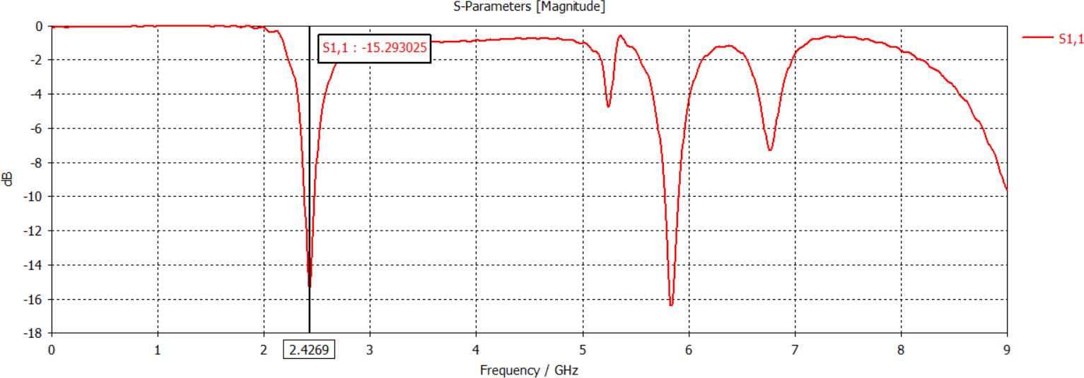

FIGURE 6.1 S11 PARAMETER FOR 2.4269GHz

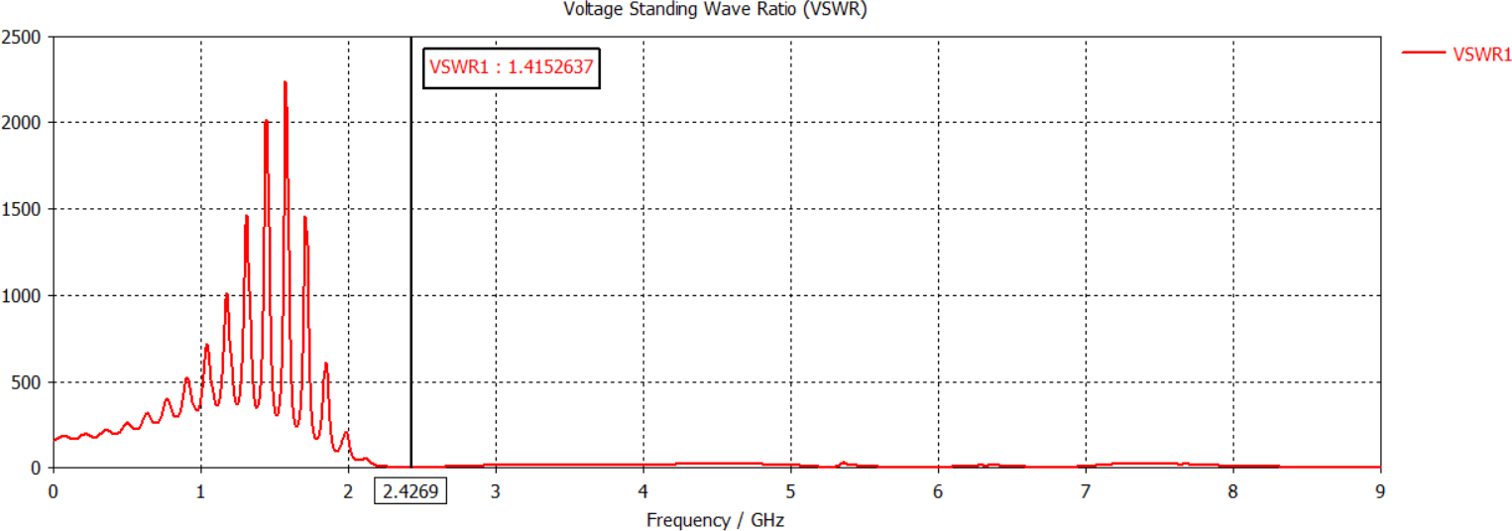

FIGURE 6.2 VSWR FOR 2.4269GHz

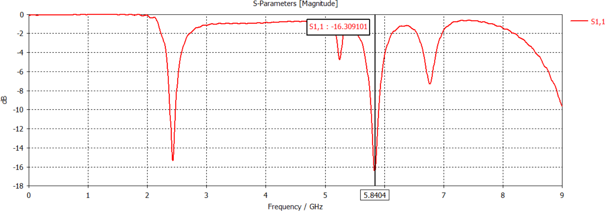

FIGURE 6.3 S11 PARAMETER FOR 5.8404GHz

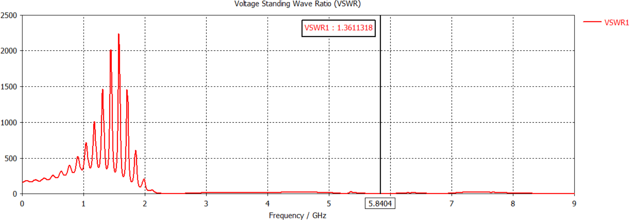

FIGURE 6.4 VSWR FOR 5.8404GHz

# GAIN AT 2.4269 GHz

From the figure 6.5, the following data are observed,

#### Radiation Pattern:

* + - * The color gradient represents the gain in dBi (decibels relative to isotropic radiator).
      * Red and orange regions indicate higher gain (stronger radiation).
      * Green to blue regions indicate lower gain (weaker radiation).
      * The pattern is almost spherical, suggesting omnidirectional characteristics which is desirable in some biomedical applications for uniform coverage.

#### Gain Scale (dBi):

* + - * The scale on the right ranges from -37.1 dBi to 2.9 dBi.
      * The peak gain (brightest point on the sphere) is approximately 2.9 dBi, as per the color mapping.

#### E-vector and H-vector (Field Orientation):

* + - * The green curve shows the E-field vector (electric field orientation).
      * The red curve shows the H-field vector (magnetic field orientation).
      * The blue arrow indicates the direction of wave propagation (Prop. Dir.).

#### Gain at 2.4269 GHz

The antenna demonstrates a maximum gain of approximately

2.9 dBi at 2.4269 GHz.

A gain of 2.9 dBi indicates that the antenna radiates energy more efficiently in specific directions than an isotropic radiator, which is beneficial in enhancing signal strength in target areas.

This level of gain is adequate for short-range biomedical applications, such as wireless body area networks (WBANs) or implantable devices, where strong omnidirectional coverage is important for maintaining communication regardless of the body’s orientation.

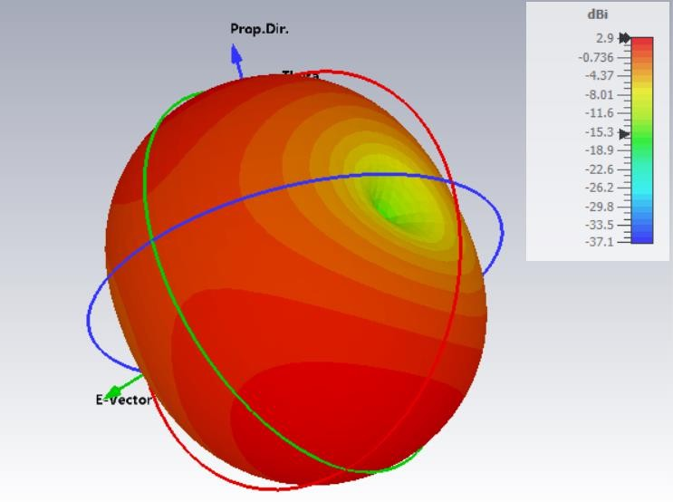

FIGURE 6.5 GAIN AT 2.4269 GHz

# GAIN AT 5.8404 GHz

From the figure 6.6, the following data are observed,

#### Radiation Pattern Representation:

* + - * The shape and color gradient across the sphere indicate how energy is radiated in different directions.
      * The intensity of color (from red to yellow) corresponds to different gain values in decibels relative to an isotropic radiator (dBi).
      * At 5.8404 GHz, the antenna exhibits anisotropic radiation, meaning it radiates more power in specific directions rather than uniformly.

#### Color Scale (Gain in dBi):

* + - * The color bar on the right ranges from -36.5 dBi (dark blue) to +3.51 dBi (bright yellow).
      * The maximum gain is approximately 3.51 dBi, located in the yellow- highlighted region on the sphere.

#### Vector Arrows:

* + - * Blue arrow labeled indicates the direction of wave propagation.
      * Green and red curves represent the E-vector (electric field) and H-vector (magnetic field) components of the radiated electromagnetic wave.
      * The E-field orientation is important for polarization and matching in communication systems.

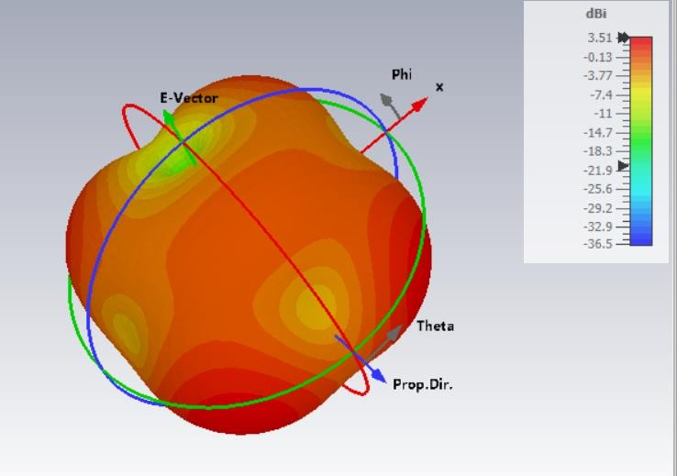

FIGURE 6.6 GAIN AT 5.8404 GHz

#### Gain at 5.8404 GHz

* + - * The antenna achieves a peak gain of 3.51 dBi at 5.8404 GHz.
      * This gain level is suitable for short- to medium-range wireless communication, enhancing signal strength in the target direction.
      * The non-uniform distribution indicates directional radiation, which can be beneficial for focused communication such as point-to-point biomedical telemetry.

### SPECIFIC ABSORPTION RATE (SAR) ANALYSIS

#### At 2.4269 GHz

The SAR distribution of the proposed implantable antenna, which resonates at **2.4269 GHz**, has been analyzed based on the **1-gram tissue standard**, which is commonly used in biomedical device compliance testing. SAR quantifies the rate at which electromagnetic energy is absorbed by biological tissue when exposed to a radiofrequency (RF) field.

As shown in the figure 6.7, the SAR distribution is presented in **dB(W/kg)** scale, highlighting the regions within the tissue that absorb the most energy. The highest SAR value observed for 1 gram of tissue is **approximately 24.7 dB(W/kg)**. Converting from dB scale, this corresponds to a **linear SAR value of approximately 295.12 W/kg**, which represents the peak absorption near the central region of the antenna structure—particularly around the inner arms of the hexagonal split-ring resonator.

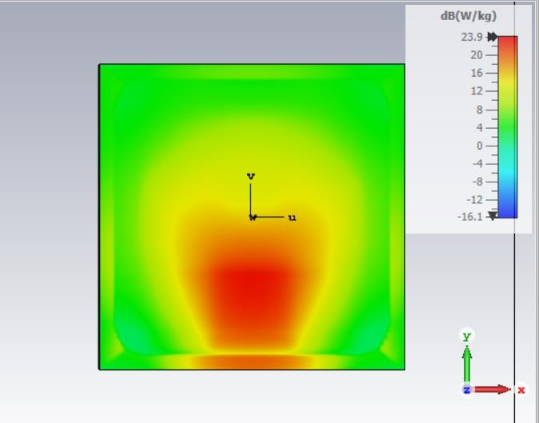

FIGURE 6.7 SAR FOR 1g AT FREQUENCY 2.4269 GHz

#### At 5.8404 GHz

The SAR analysis for the proposed implantable antenna, operating at a resonant frequency of **5.8404 GHz**, is shown in the figure 6.8. The evaluation is conducted based on the **1-gram tissue standard**, in accordance with biomedical RF safety assessment protocols.

The SAR distribution is visualized using a color gradient scale in **dB(W/kg)**, with the maximum recorded value reaching approximately **23.9 dB(W/kg)**. When converted to a linear scale, this equates to a SAR value of approximately **245.47 W/kg**. This high-intensity absorption is concentrated at the central region of the antenna, especially near the slots and inner resonator arms of the hexagonal metamaterial structure, where the electric fields are strongest due to the compact, high-Q geometry.

This localized concentration of SAR is a direct result of the strong electromagnetic confinement enabled by the metamaterial-inspired design. The surrounding areas, marked by the transition from red/yellow to green/blue on the SAR map, experience significantly lower levels of power absorption.

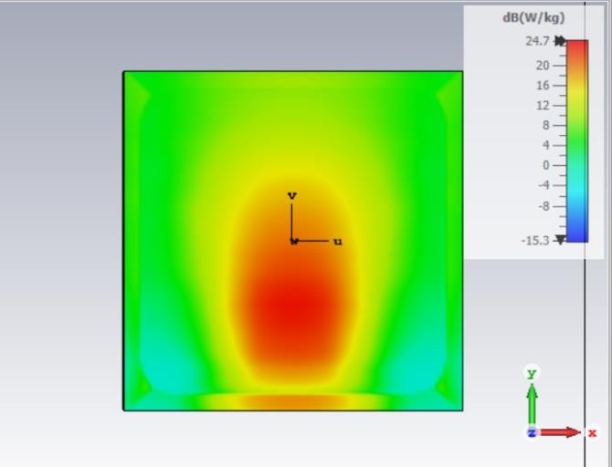

FIGURE 6.8 SAR FOR 1g AT FREQUENCY 5.8404 GHz

|  |  |  |  |  |  |  |
| --- | --- | --- | --- | --- | --- | --- |
| **S.no** | **Resonant Freq uency**  **(GHz)** | **Return loss (S11) dB** | **VSWR** | **Gain (dBi)** | **Bandwi dth**  **(MHz)** | **SAR**  **dB(W/ kg)** |
| 1 | 2.4269 | -15.701238 | 1.39244 | 3.51 | 97.3 | 24.7 |
| 2 | 5.8404 | -16.074533 | 1.37286 | 2.9 | 130.5 | 23.9 |

TABLE 6.1 CONSOLIDATED RESULT

# CHAPTER 7 CONCLUSION

A compact CSRR-loaded dual-band E-shaped slot microstrip antenna (25 × 25 × 1.08 mm) was designed for biomedical applications. It exhibits two resonant frequencies at ISM band 2.4269 GHz and 5.8404 GHz for biomedical telemetry, implantable sensors, and WBANs. Both frequencies show return loss values below -15 dB, indicating excellent impedance matching. The integration of CSRRs enabled effective miniaturization and enhanced dual-band performance. With its compact size, efficient radiation, low SAR and reliable dual-band operation, the proposed antenna is well-suited for next-generation wearable and implantable biomedical communication systems.

# REFERENCES

1. R. Rebelo, A.I. Barbosa, V.M. Correlo, R.L. Reis, An Outlook on “Implantable Biosensors for Personalized Medicine, in: In Engineering”, 7, Elsevier Ltd., 2021, pp. 1696–1695.
2. N. Filip, I. Radu, B. Veliceasa, C. Filip, M. Pertea, A. Clim, A.C. Pinzariu, I.

C. Drochioi, R.L. Hilitanu, I.L. Serban, “Biomaterials in Orthopedic Devices: Current Issues and Future Perspectives”, in: In Coatings, 12, MDPI, 2022.

1. S.J. Edwards, V. Wakefield, T. Jhita, K. Kew, P. Cain, G. Marceniuk, “Implantable cardiac monitors to detect atrial fibrillation after cryptogenic stroke: a systematic review and economic evaluation”, Health Technol. Assess. 24 (5) (2020) v-184
2. K.Y. Wu, J.K. Fujioka, P. Daigle, S.D. Tran, “The use of functional biomaterials in aesthetic and functional restoration in orbital surgery, in: In Journal of Functional Biomaterials”, 15, Multidisciplinary Digital Publishing Institute (MDPI), 2024,.
3. S. Ahlawat, N. Singh, B.K. Kanaujia, K. Rambabu, “A dual-band differential intraoral antenna and system for wireless data and radiative near-field power transfer”, IEEE Trans. Antennas Propag. 71 (3) (2023) 2145–2157
4. J. Nivitha Angeline, S. Allin Christe, “Design and analysis of a small implantable antenna for blood glucose monitoring”, ICDCS 2020 - 2020 5th Int. Conf. Devices Circuits Syst. (2020) 120–124
5. S.M.A. Shah, M. Zada, J. Nasir, Owais, H. Yoo,” Ultraminiaturized Triband Antenna with Reduced SAR for Skin and Deep Tissue Implants”, IEEE Trans. Antennas Propag. 70 (9) (2022) 8518–8529
6. T. Shaw, B. Mandal, D. Mitra, P.K.B. Rangaiah, M.D. Perez, R. Augustine, “Metamaterial integrated highly efficient wireless power transfer system for implantable medical devices”, AEU - Int. J. Electron. Commun. 173 (2024),
7. A. Iqbal, M. Al-Hasan, I. ben Mabrouk, T.A. Denidni,” Deep-implanted MIMO antenna sensor for implantable medical devices”, IEEE Sens. J. 23 (3) (2023)
8. ] A.Z.A. Zaki, E.K.I. Hamad, T.G. Abouelnaga, H.A. Elsadek, S.A. Khaleel,

A.J.A. AlGburi, Z. Zakaria,”Design and modeling of ultra-compact wideband implantable antenna for wireless ISM band”, Bioengineering 10 (2) (2023)

1. D.Jing, H. Li, X. Ding, W. Shao, S. Xiao, “Compact and Broadband Circularly Polarized Implantable Antenna for Wireless Implantable Medical Devices”, IEEE Antennas Wirel. Propag. Lett. 22 (6) (2023) 1236–1240
2. X. Hu, Z. Liu, G. Li,”Implantable devices based on ultra-wideband miniaturized implantable antenna for biotelemetry application”, 2023 Int. Appl. Comput. Electromagn. Soc. Symp. . (ACES-China) (2023)
3. M. Al-Hasan, P.R. Sura, A. Iqbal, J.J. Tiang, I. ben Mabrouk, M. Nedil, “Low-profile dual-band implantable antenna for compact implantable biomedical devices”, AEU - Int. J. Electron. Commun. (2021)